

**SEMESTER A202**

STIA1123 PROGRAMMING 2

**ASSIGNMENT 3**

**NAME :**

NOR AIN LIDYIA NATASHA BINTI FAUZI

**MATRIC NO** **:**

**269423**

**GROUP** **:**

C

**COURSE :**

BACHELOR OF SCIENCE INFORMATION TECHNOLOGY

**SEMESTER :**

2

**COMPANY BACKGROUND**

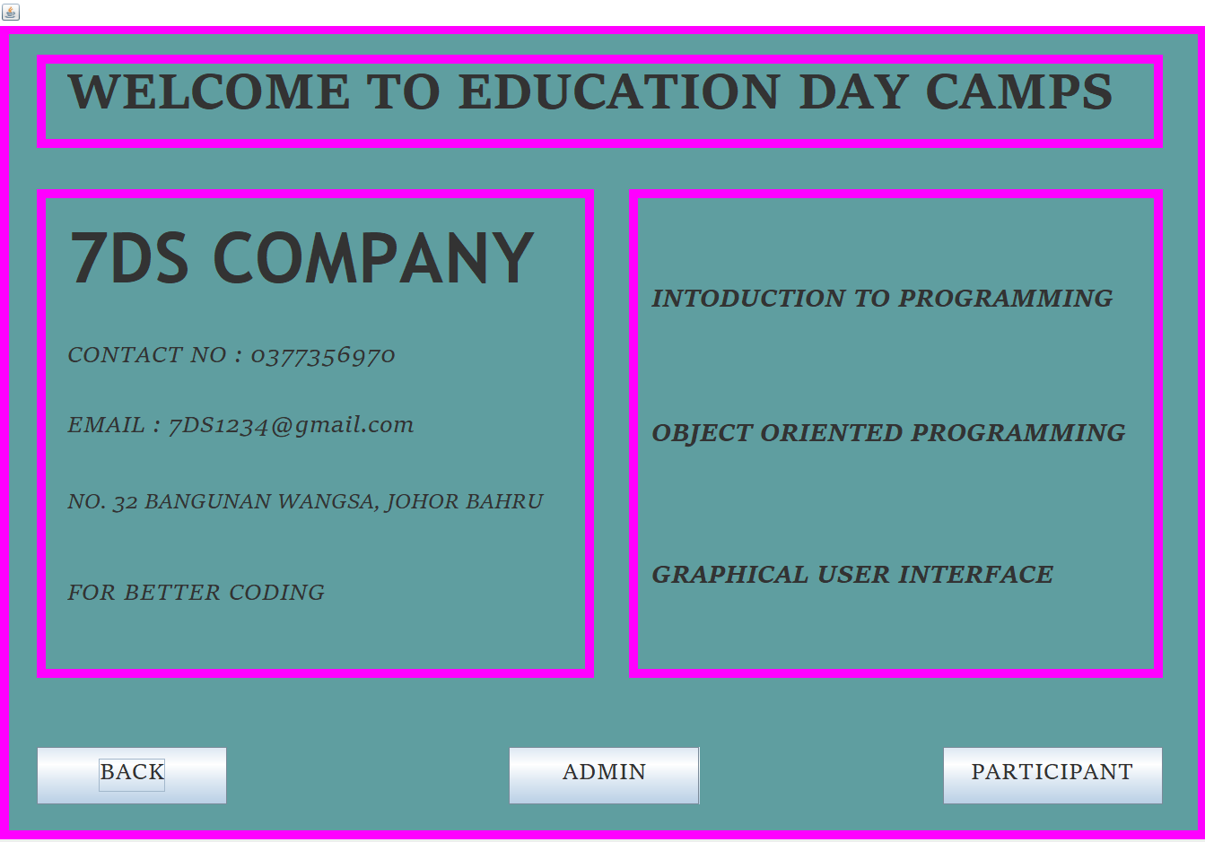

**LOGIN**

First Enter the User ID in Text field and Enter Password. Then click button LOGIN.

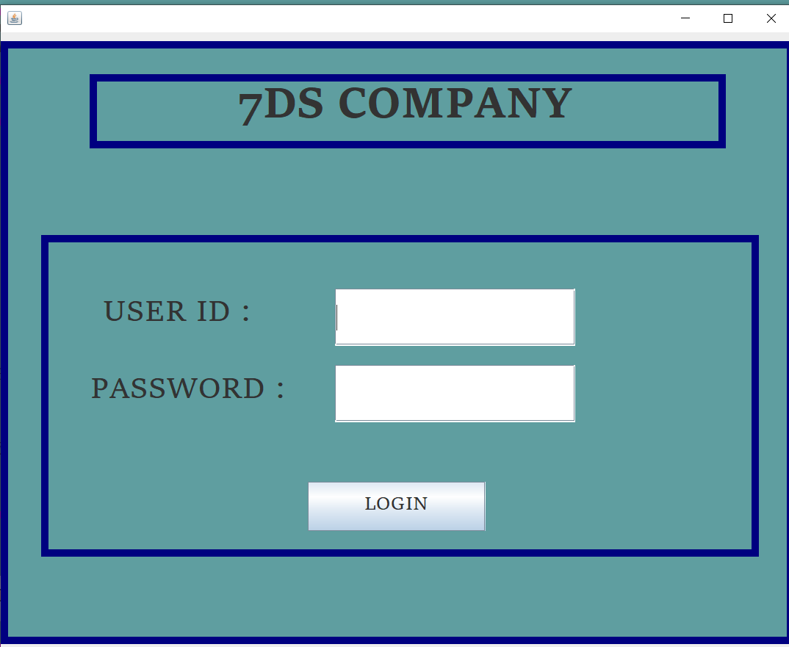

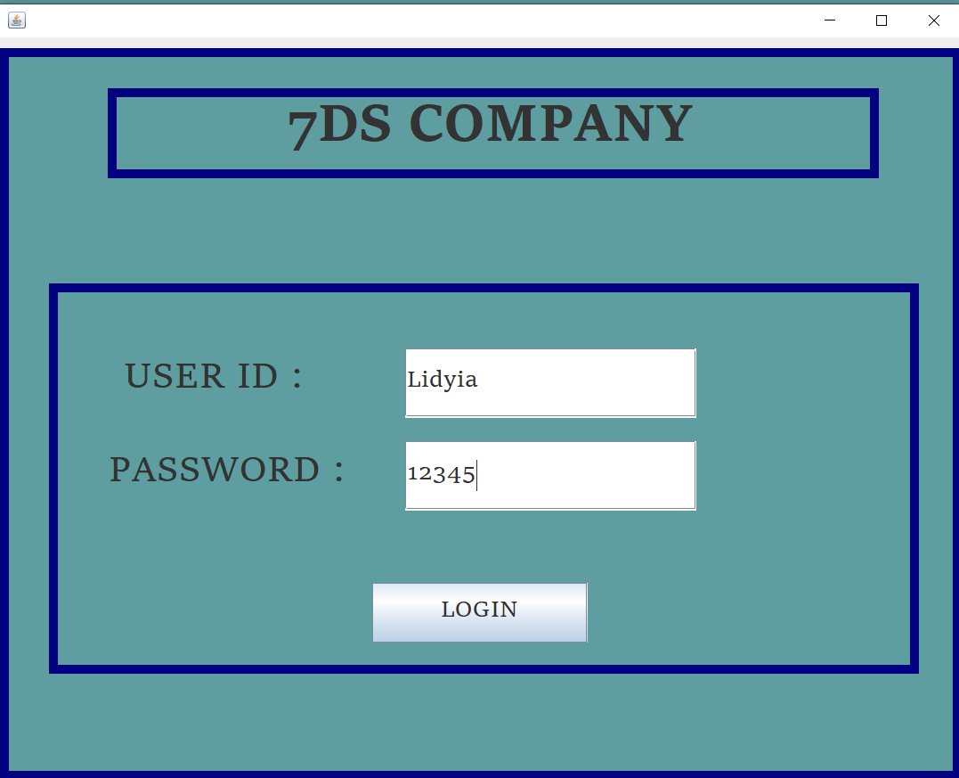

Then, will pop-up “Login Successful”.

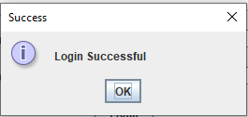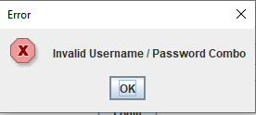

**FACILITATOR REGISTRATION**

First enter the Facilitator name, surname, address, ID No, Camps instruction, Salary and Gender in the Text field. Then click the **Add Record** button. Then, the information will appear in the table.

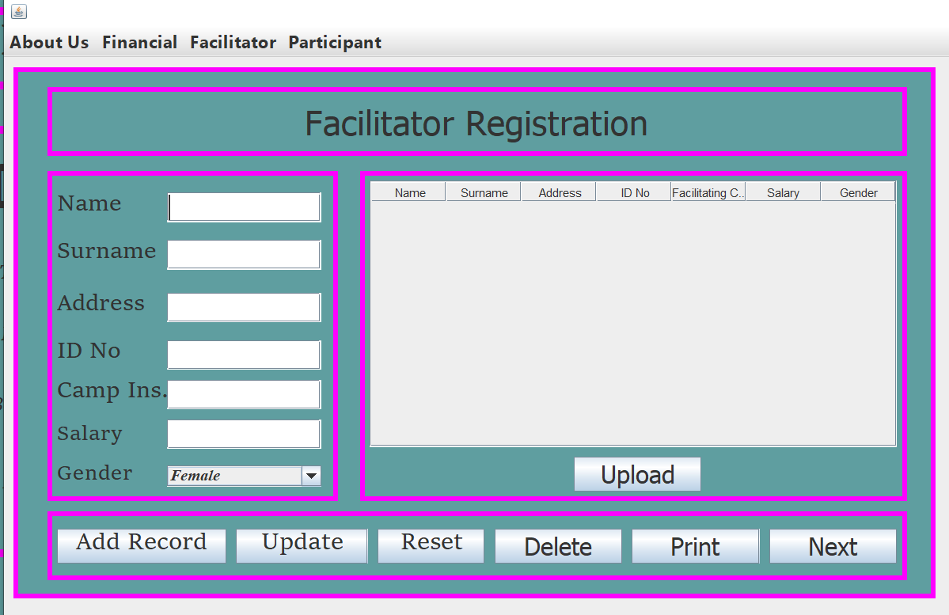

* **ADD RECORD**

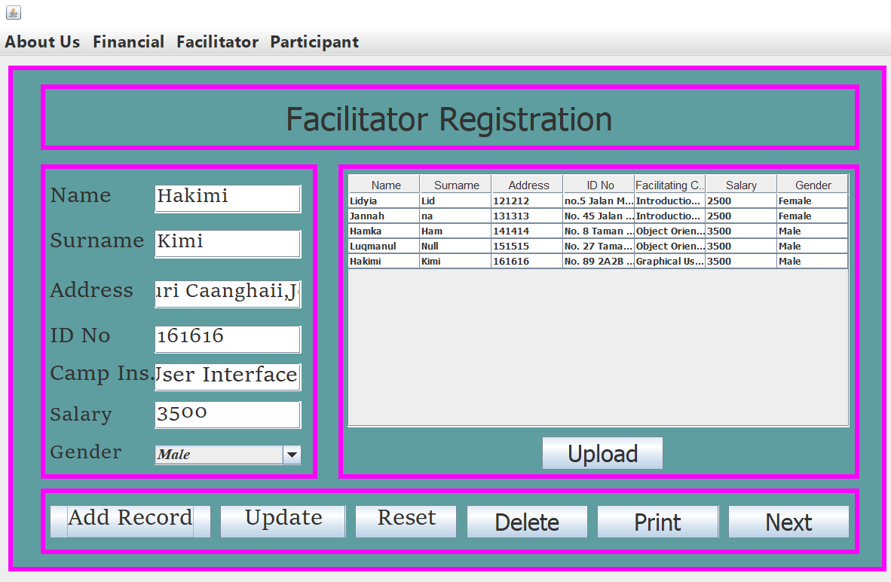

* **UPDATE**

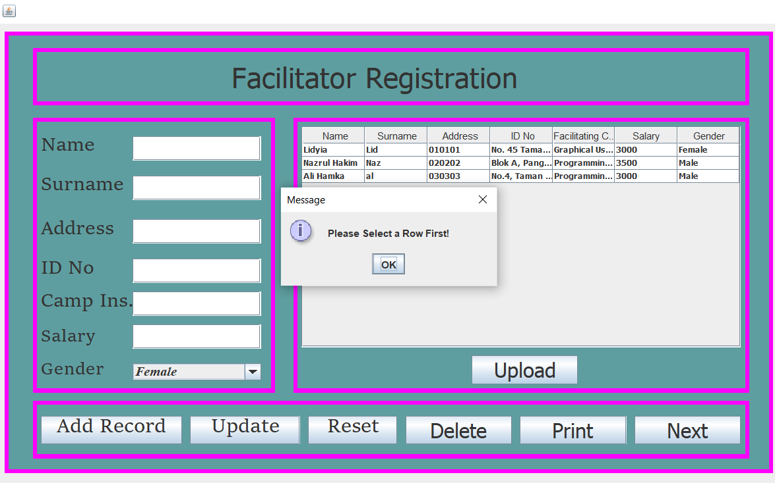

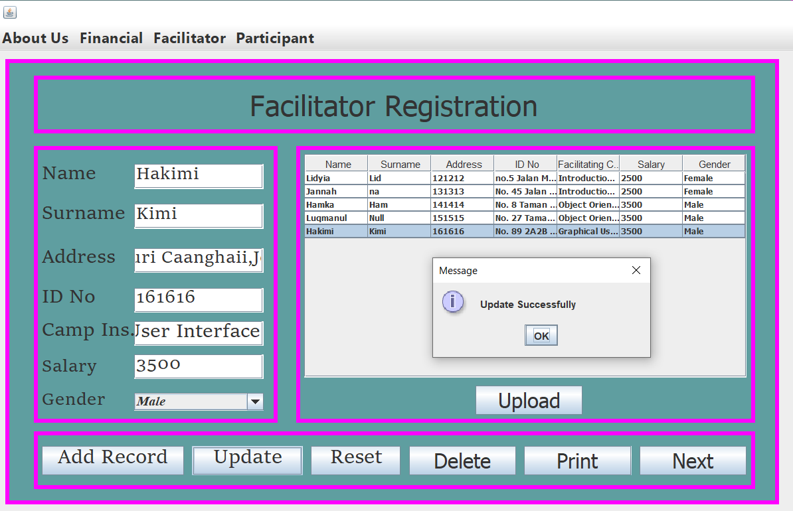

* **RESET**

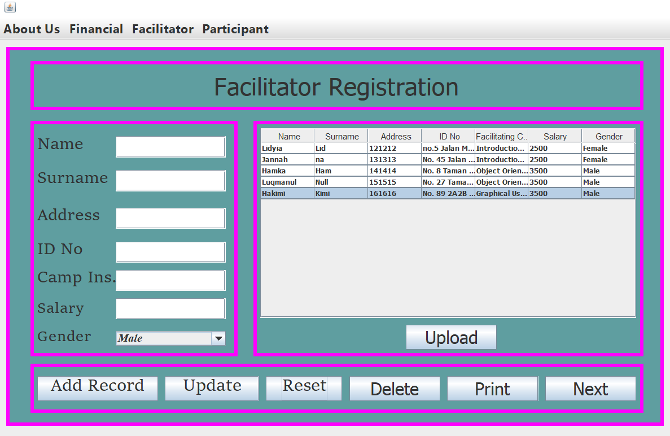

* **DELETE**

First you have to select row at table which one want to delete then click button DELETE, if you don’t click row to delete it will pop-up “Select a row to delete” then click OK



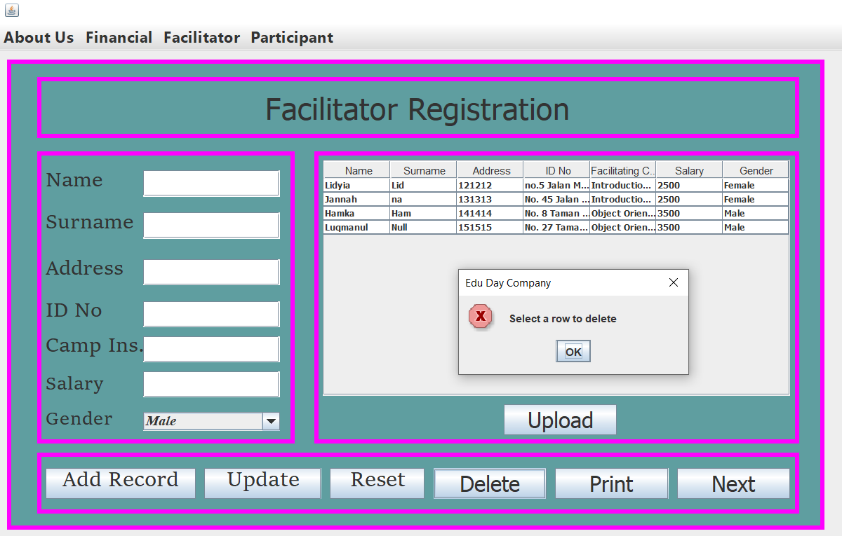

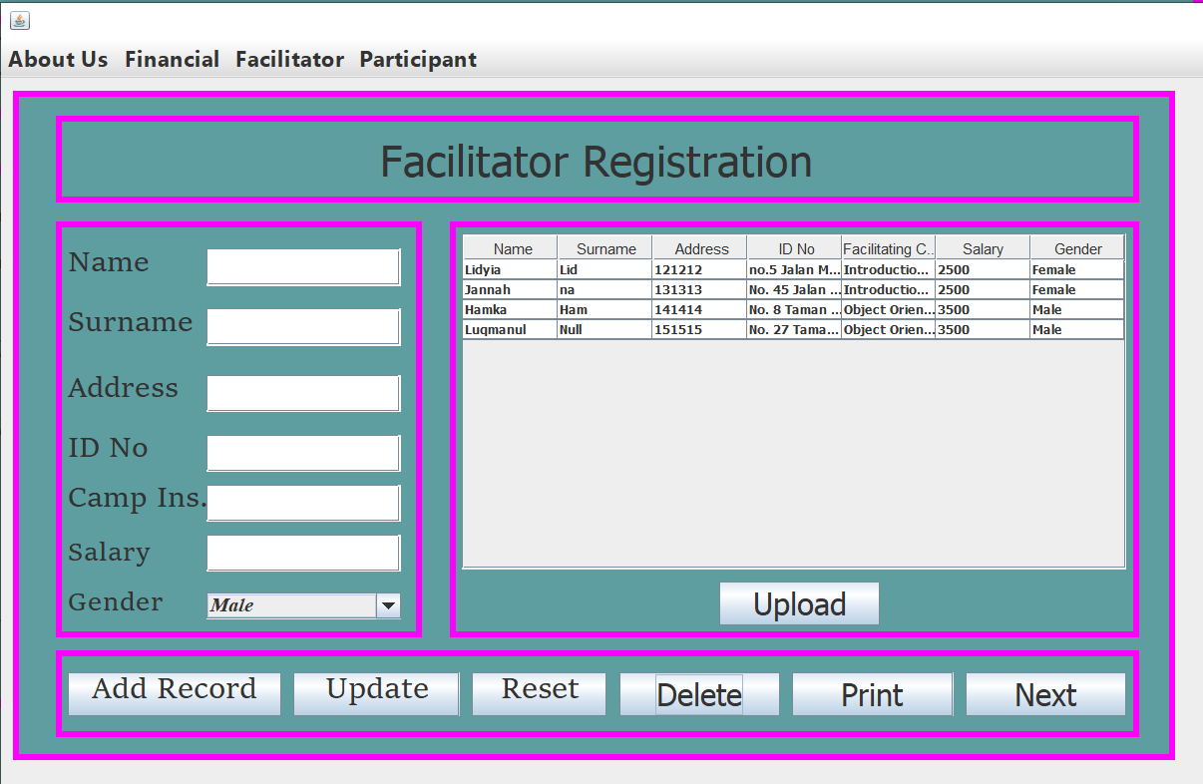

* **UPLOAD**

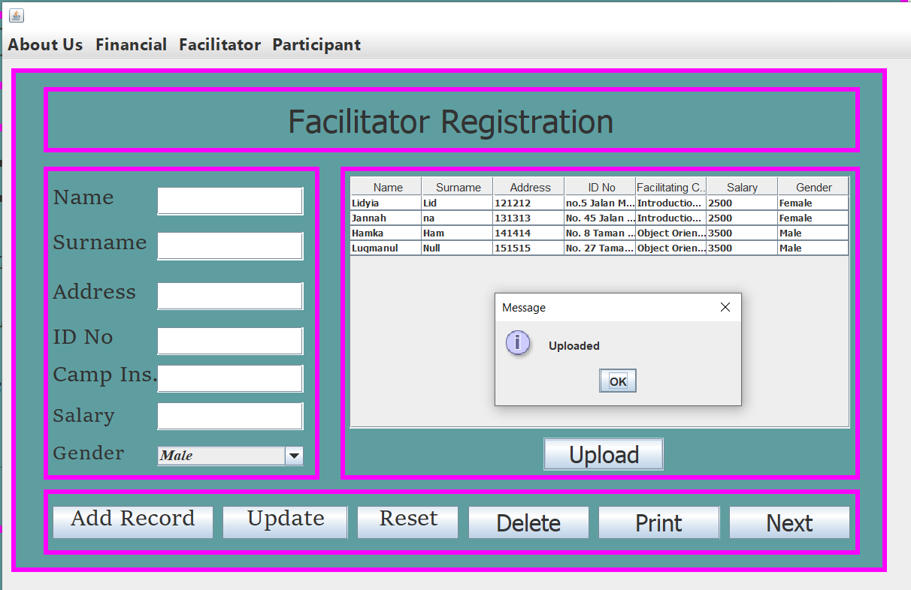

* **PRINT**

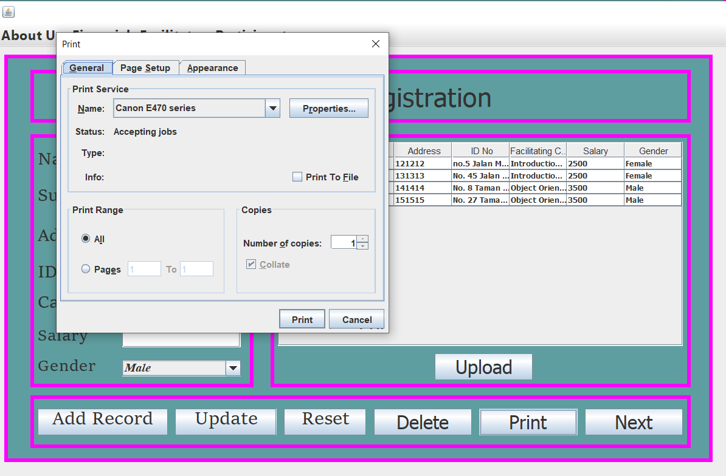

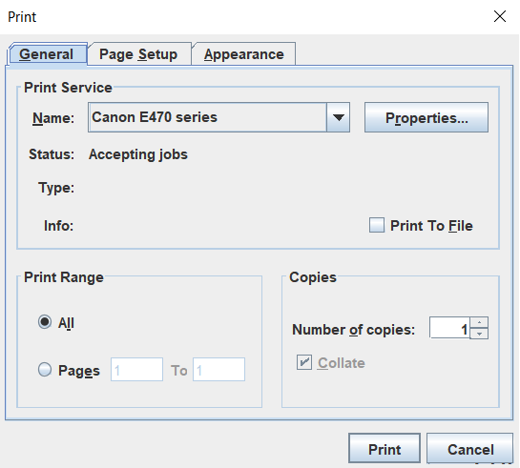

**FINANCE**

* **TOTAL**

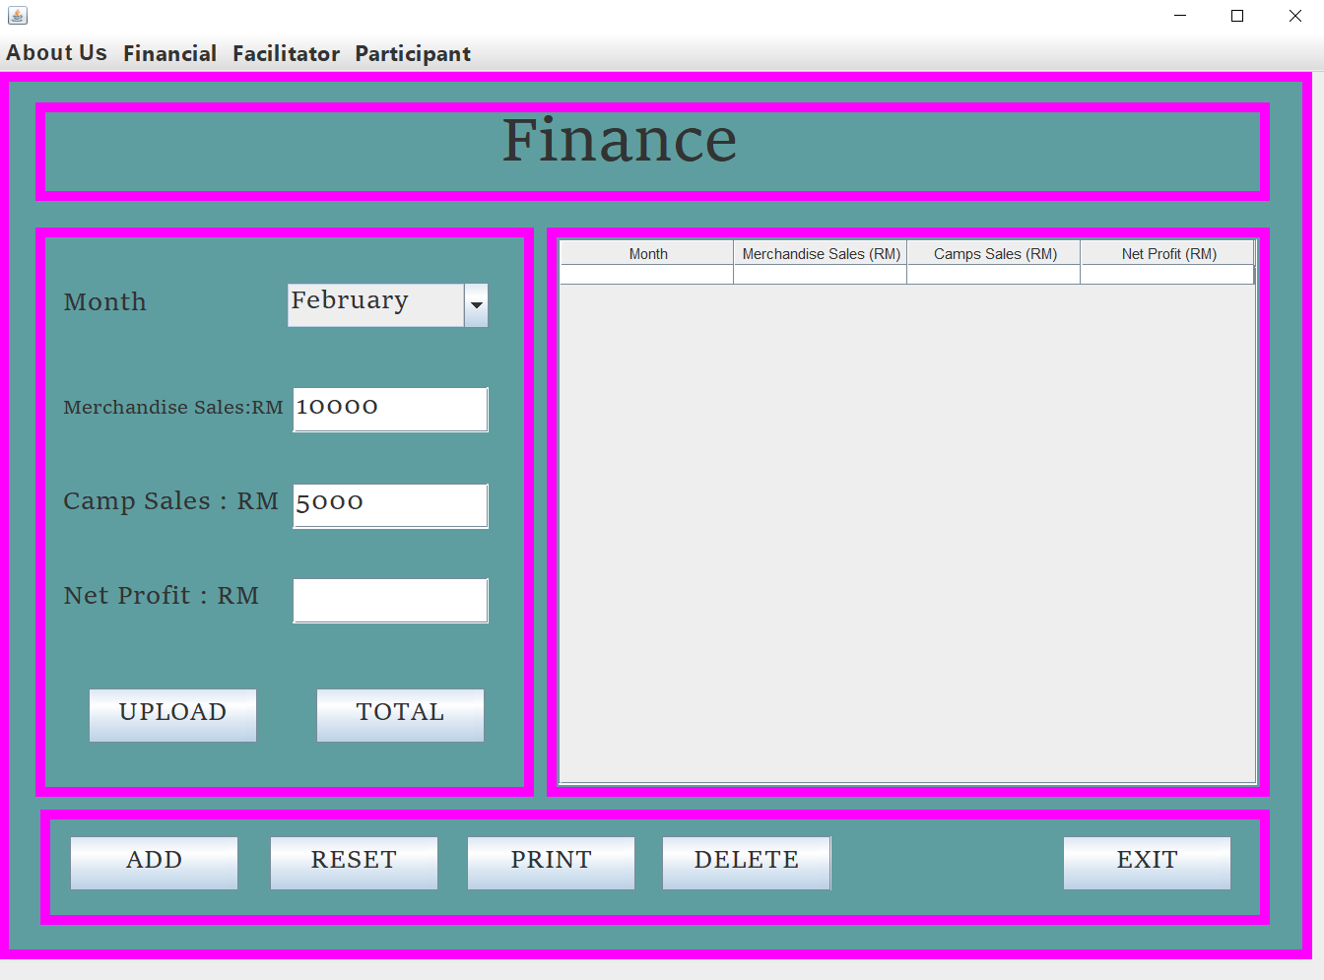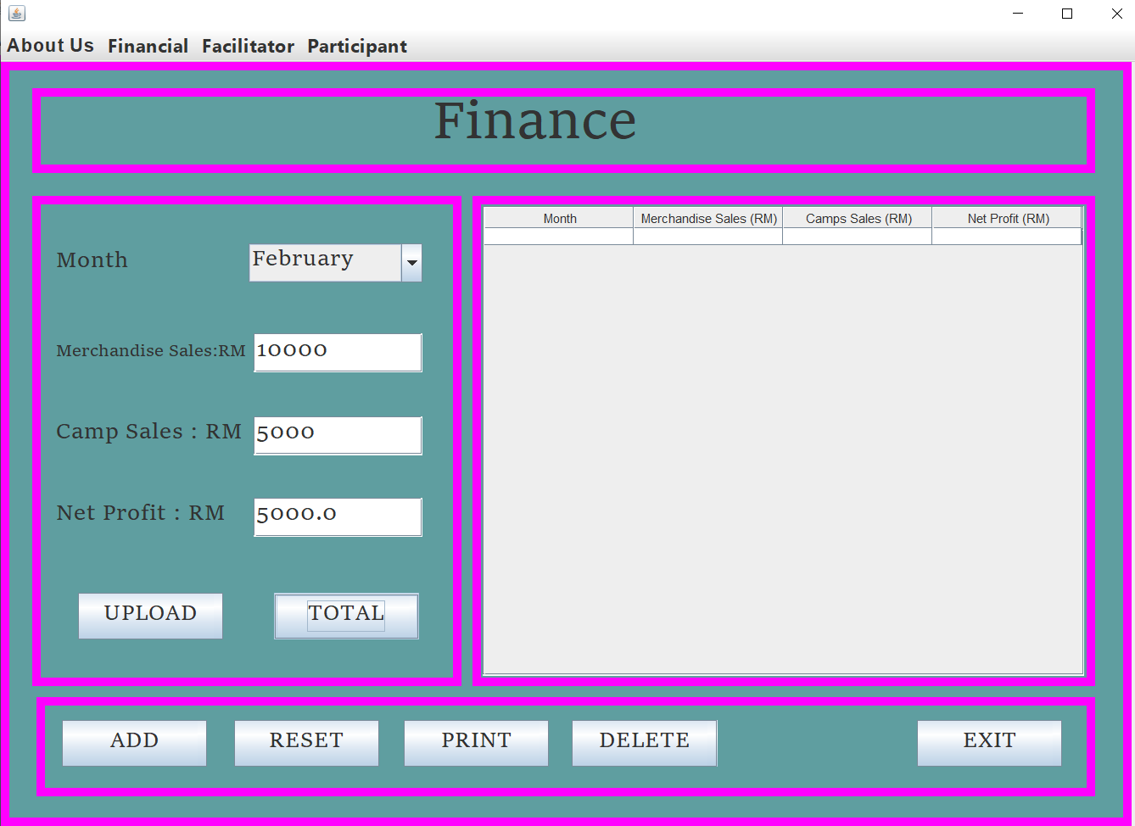

* **ADD RECORD**

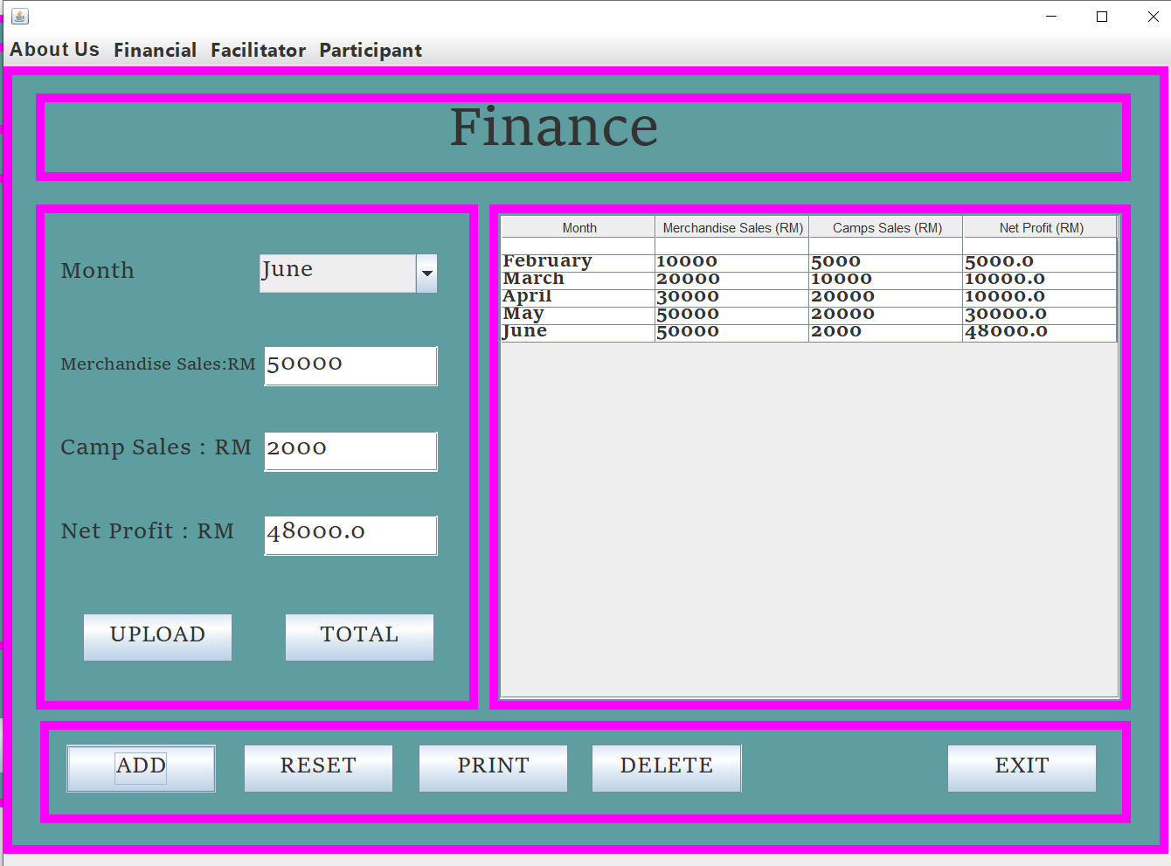

* **UPLOAD**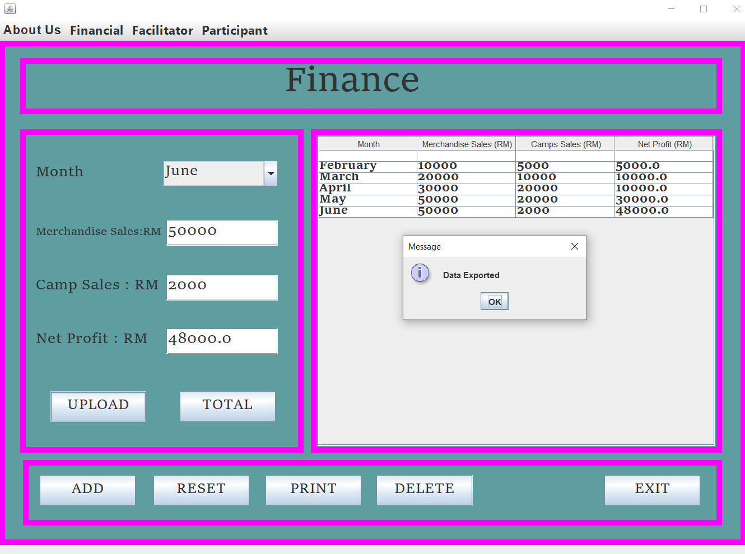
* **RESET**

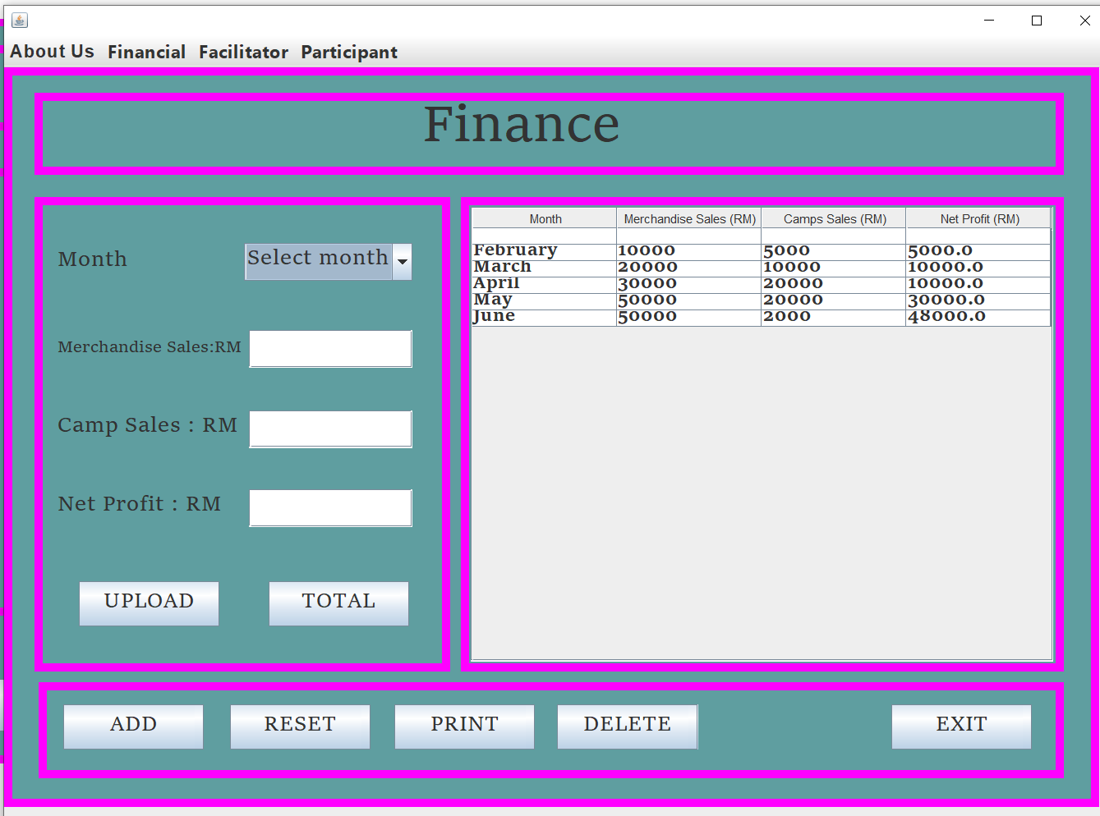

**DELETE**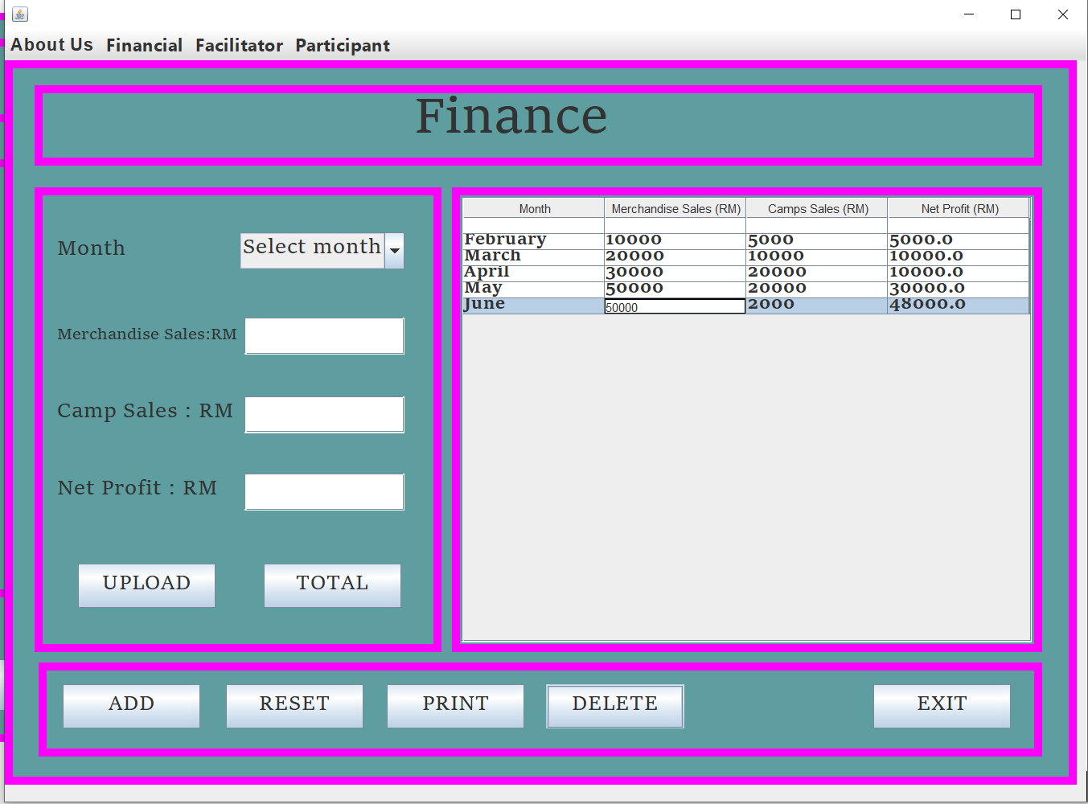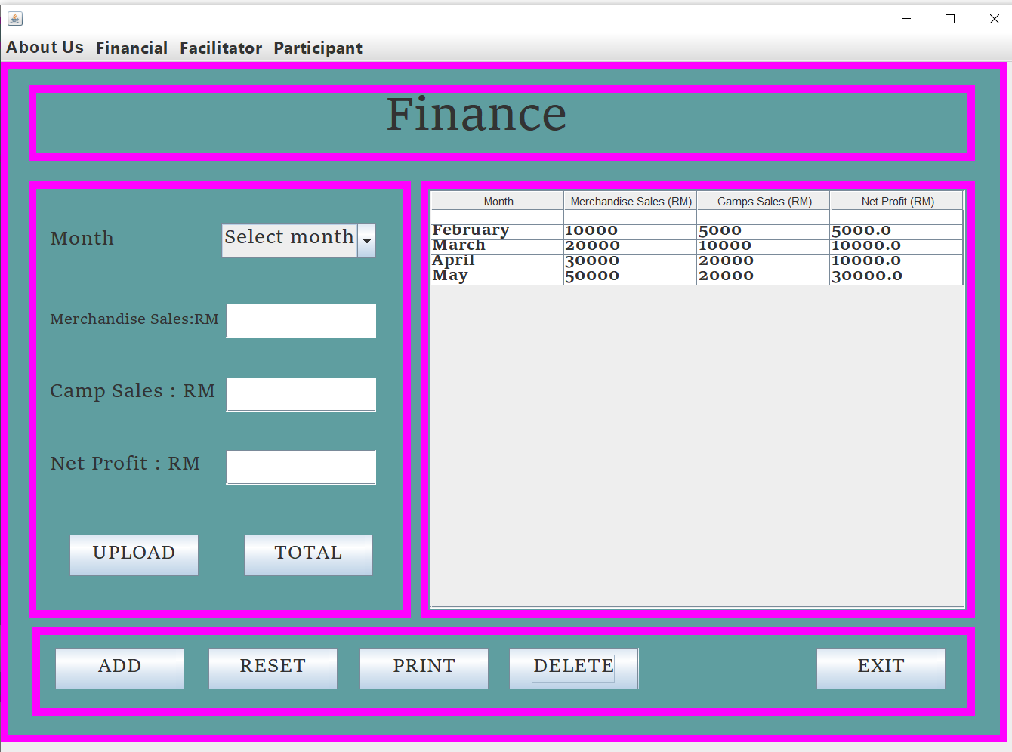

* **EXIT**

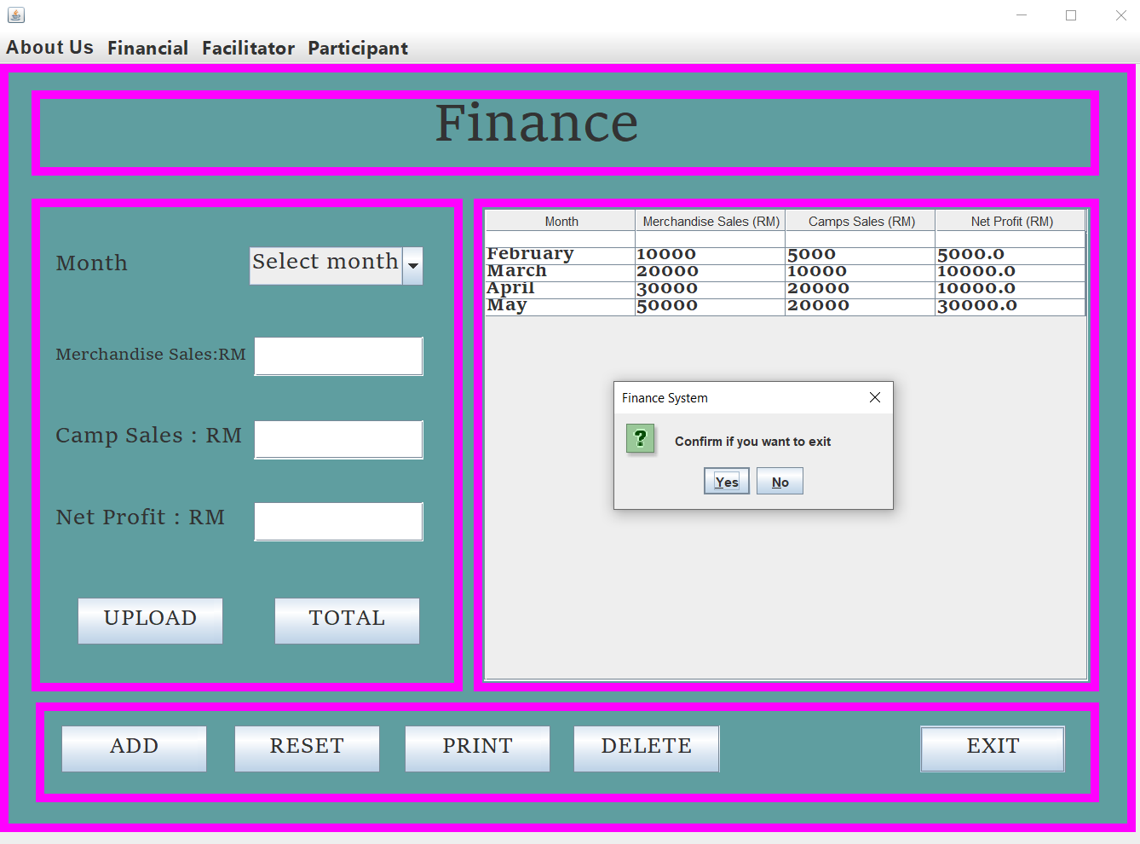

**ADVERTISEMENT**

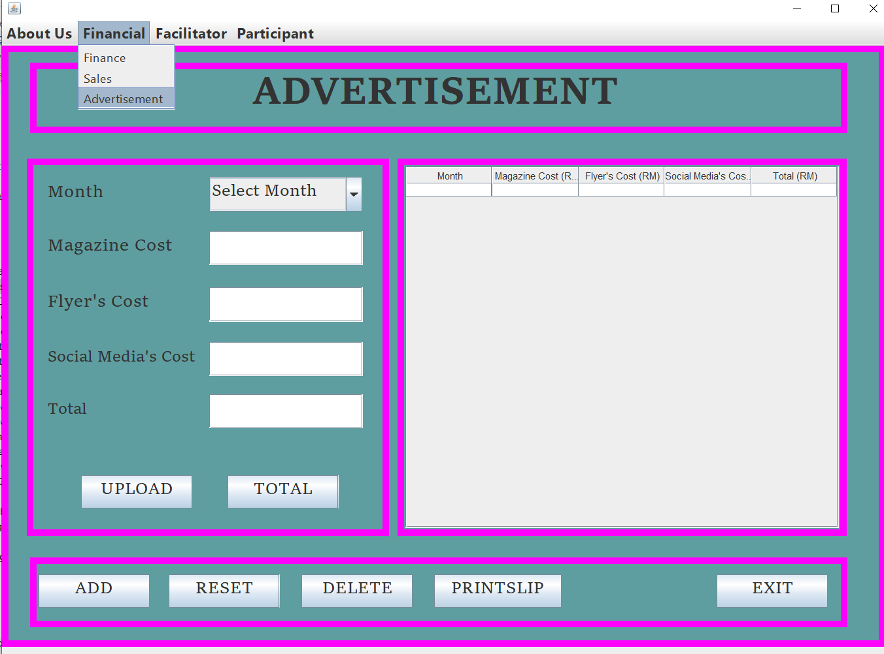

* **TOTAL**

First enter the Month, enter the Magazine Cost, enter the Flyer’s Cost, and Social Media’s Cost then click button TOTAL to get the total.

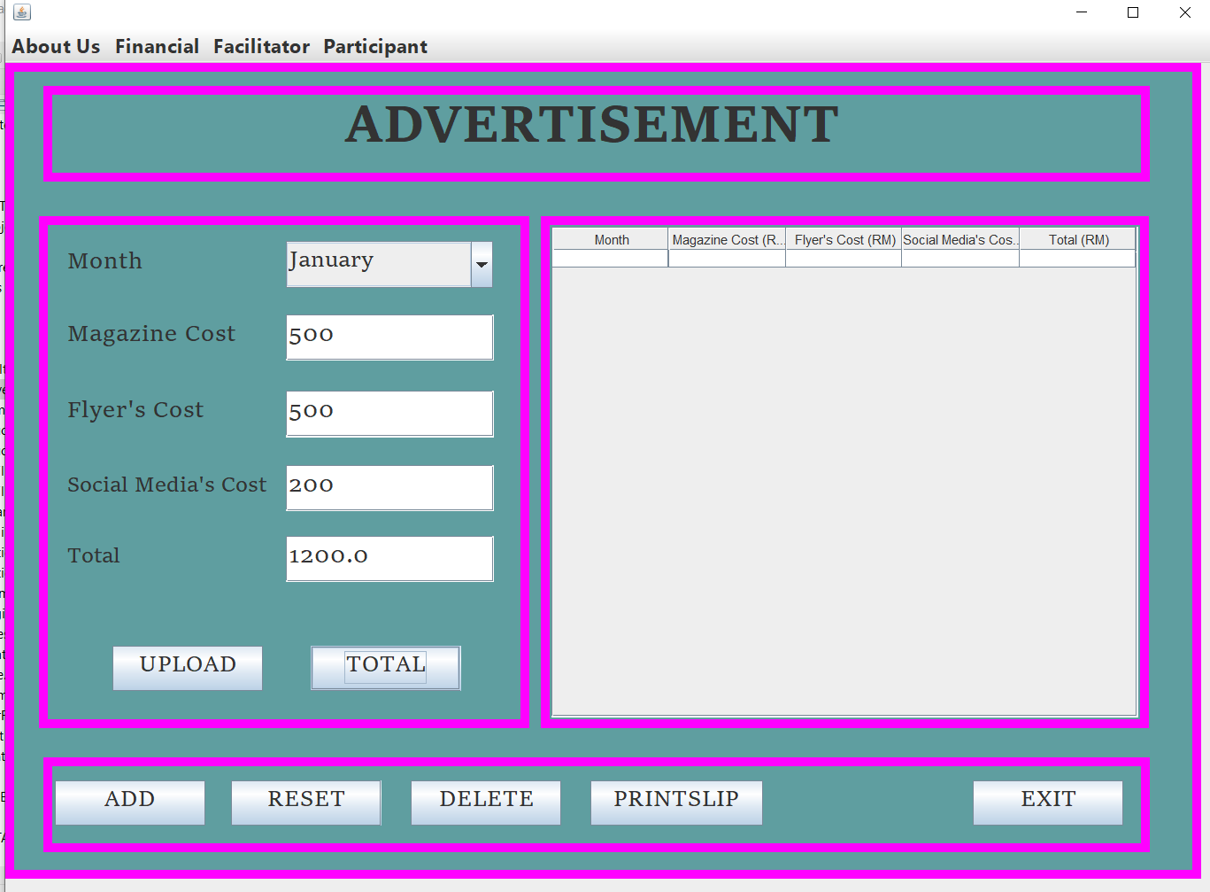

* **ADD RECORD**

First Enter Month, Enter Magazine, Flyer’s Cost, Sosial Media’s Cost and Total. Then click button ADD.

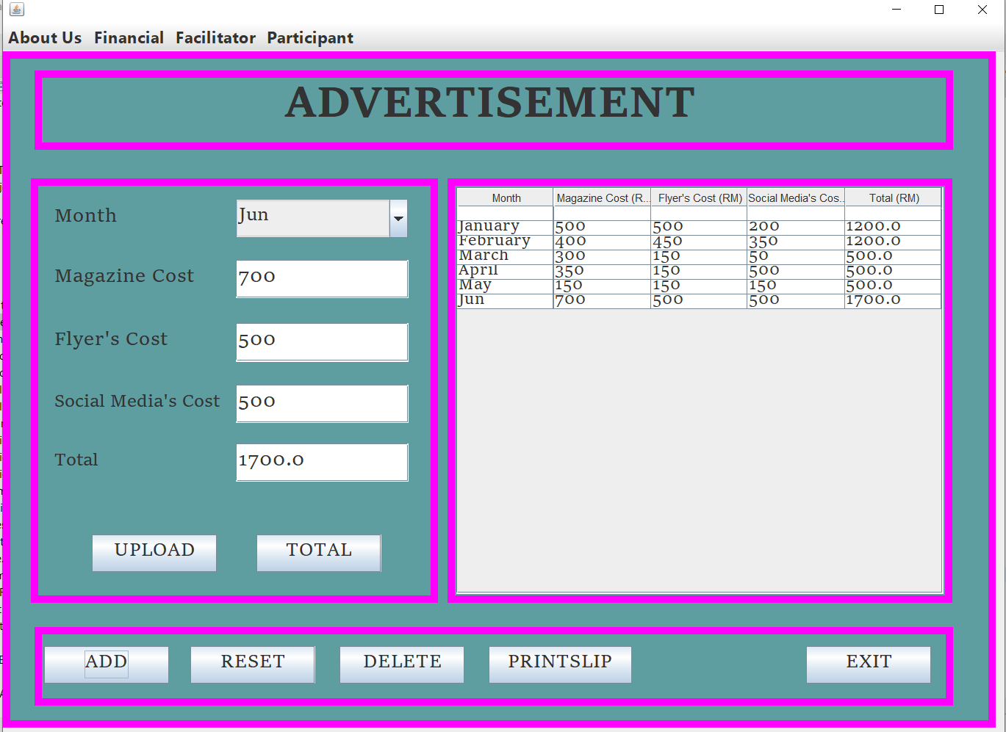

* **UPLOAD**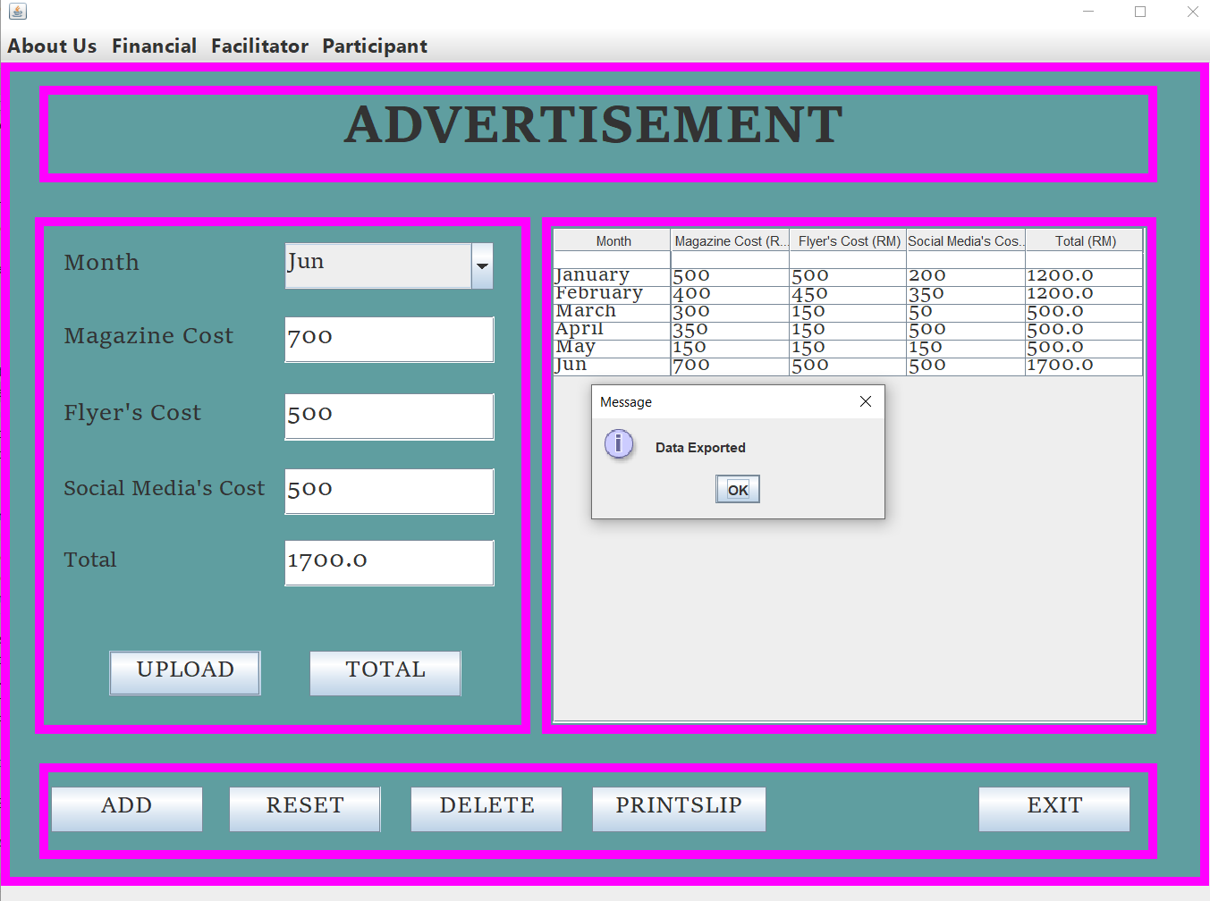
* **RESET**

Click button RESET when don write data or key in data. So you don’t have to clean

one by one.

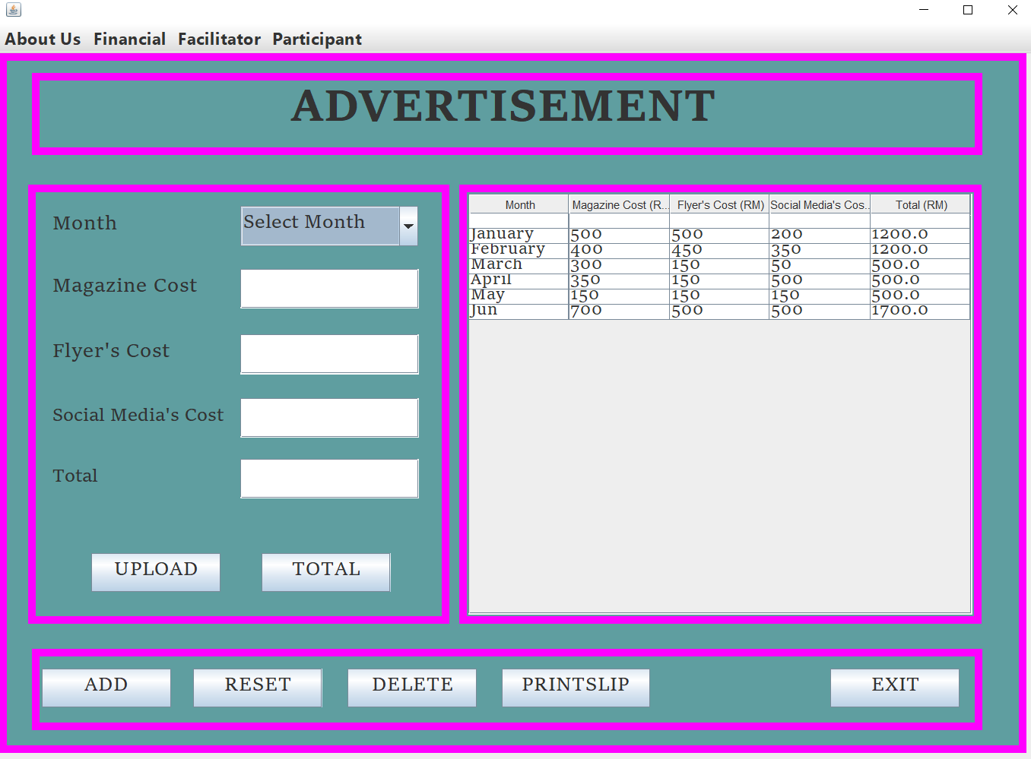

* **DELETE**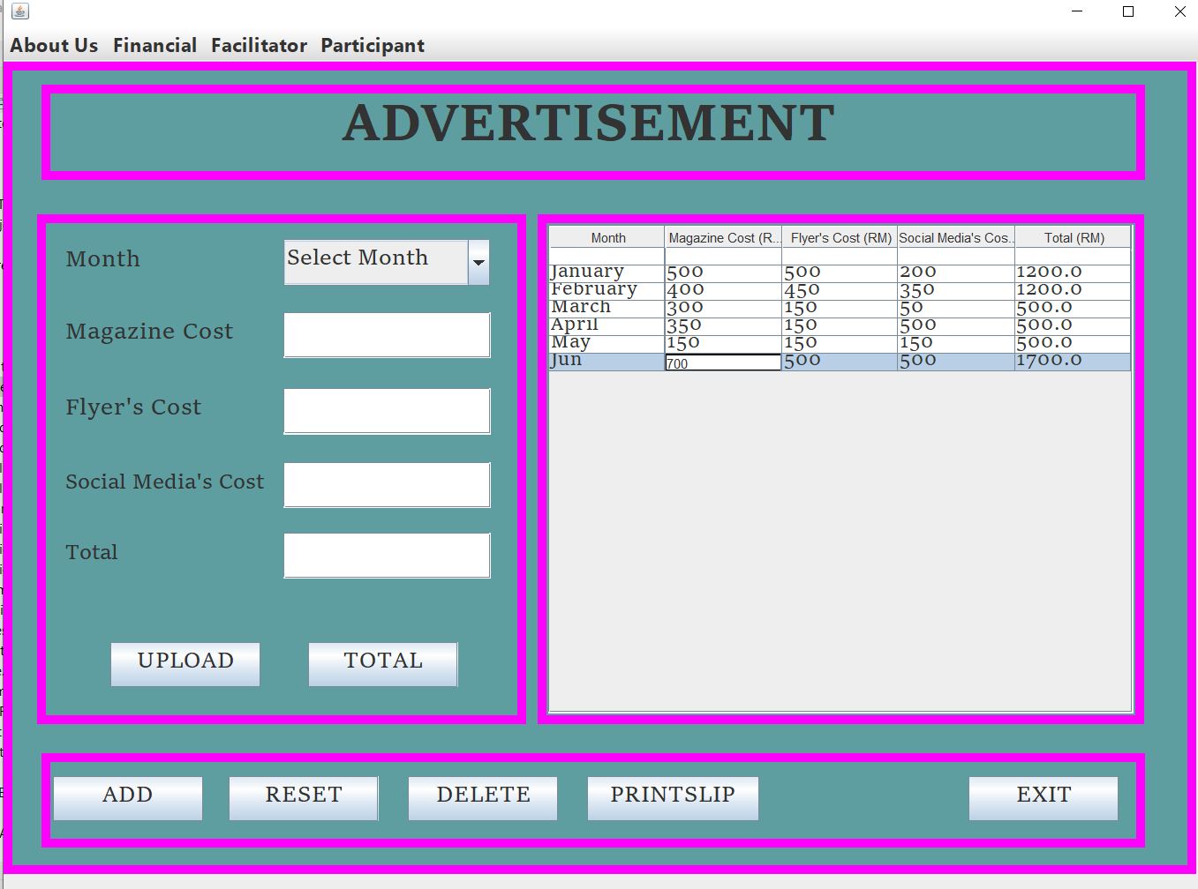

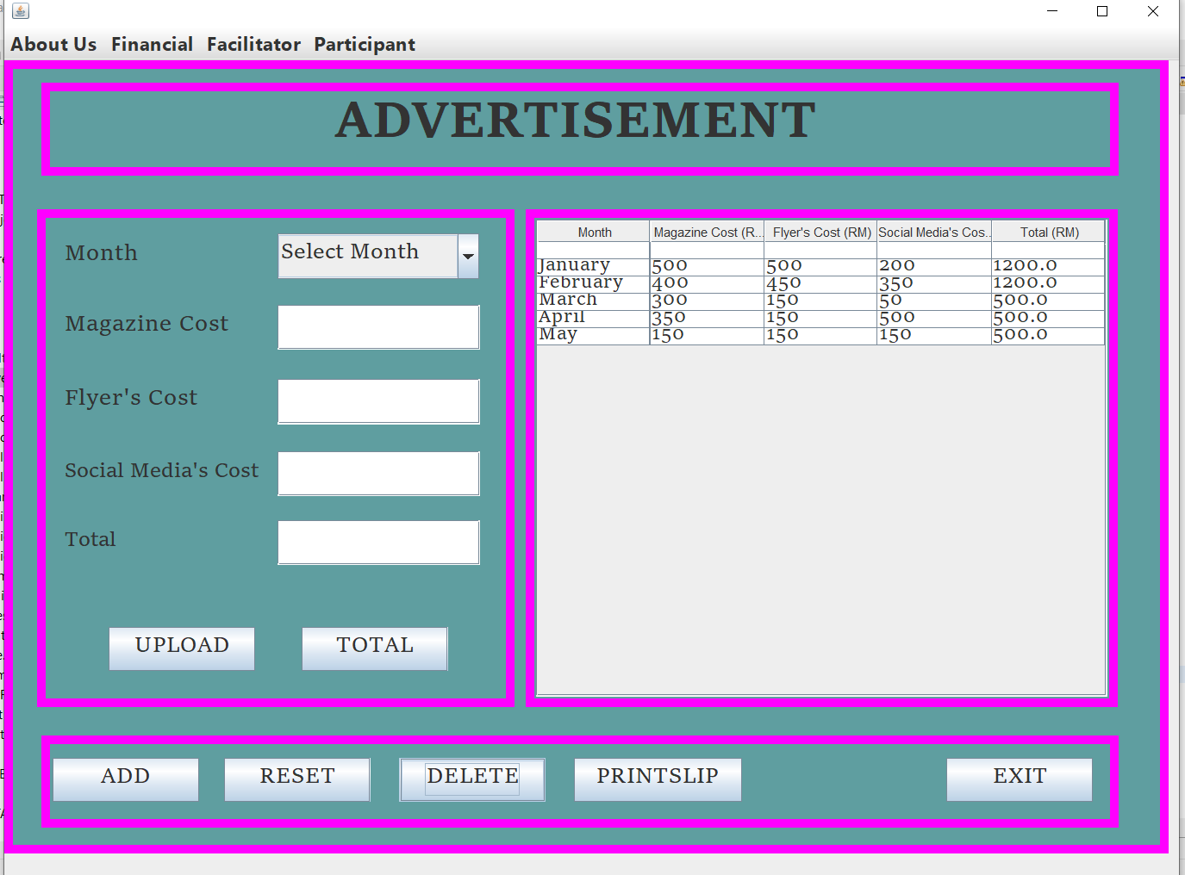

* **EXIT**

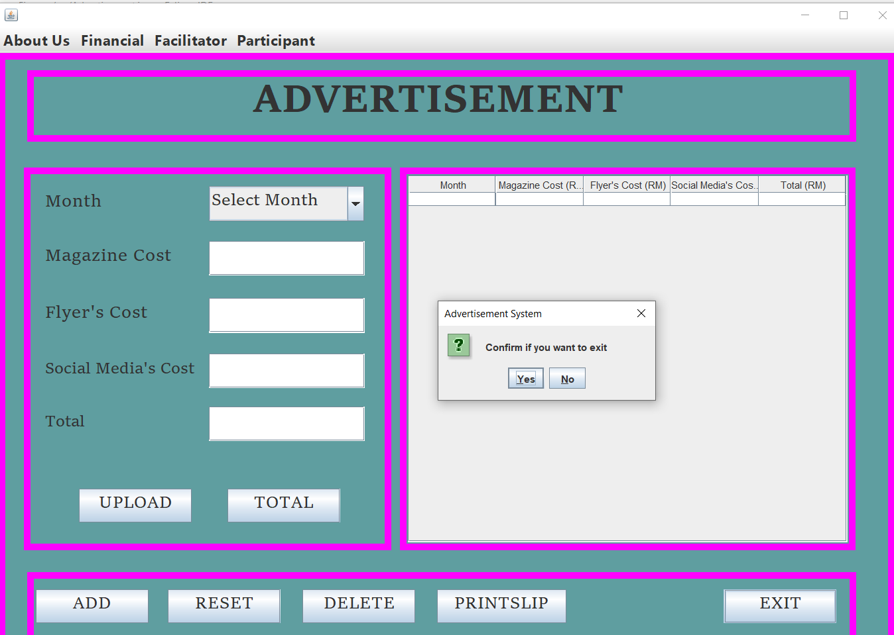

**SALES**

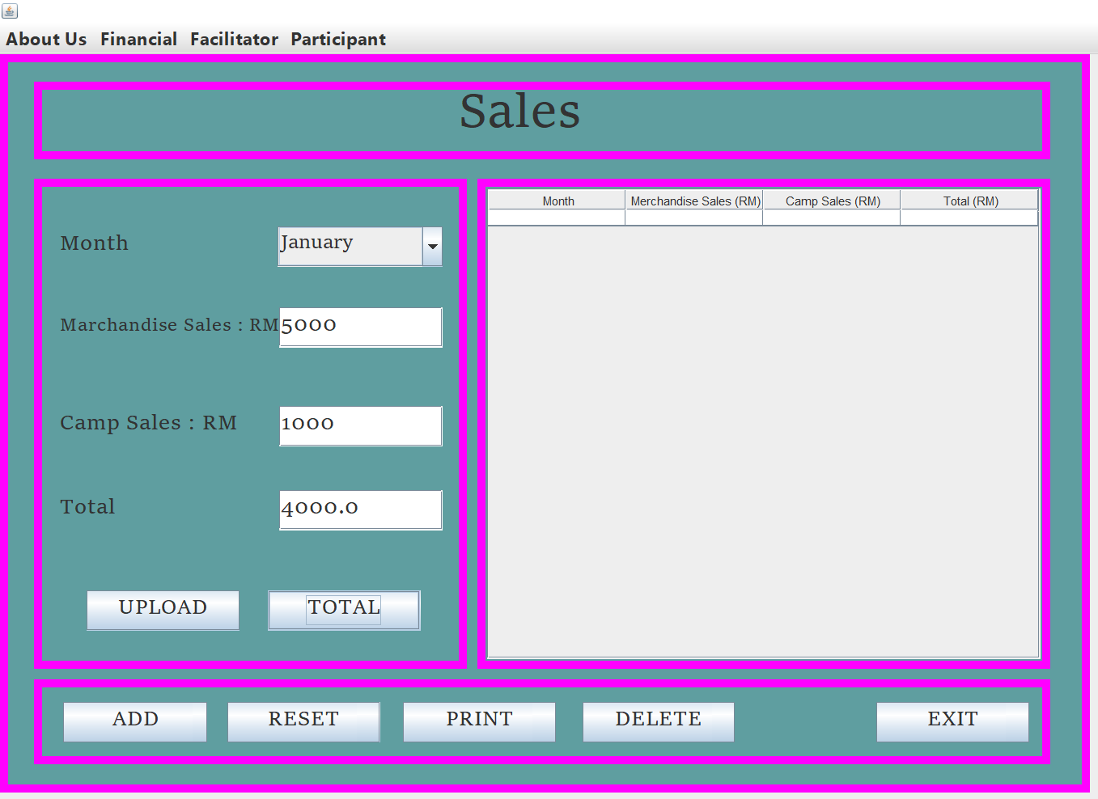

* **TOTAL**

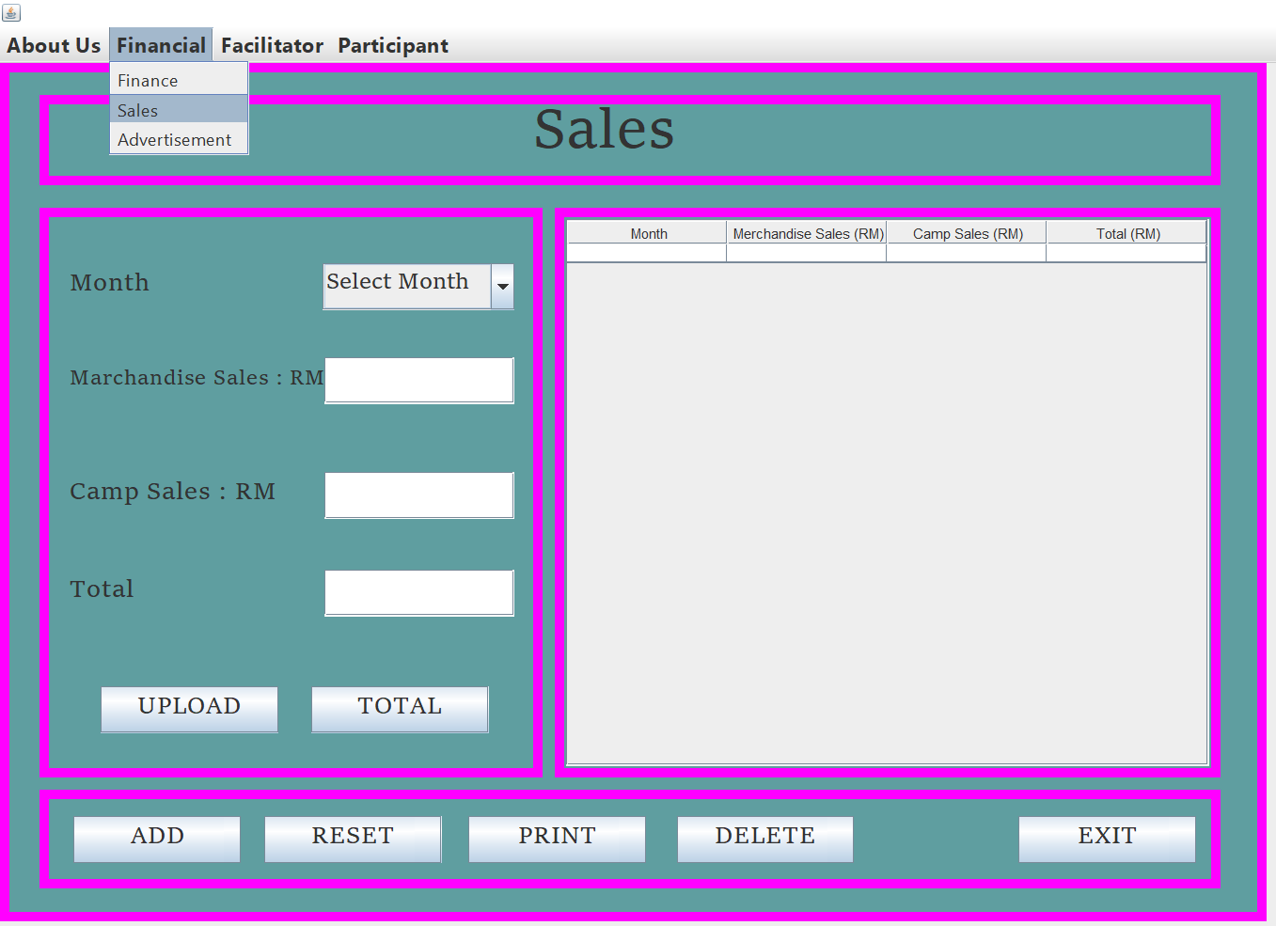

* **ADD RECORD**

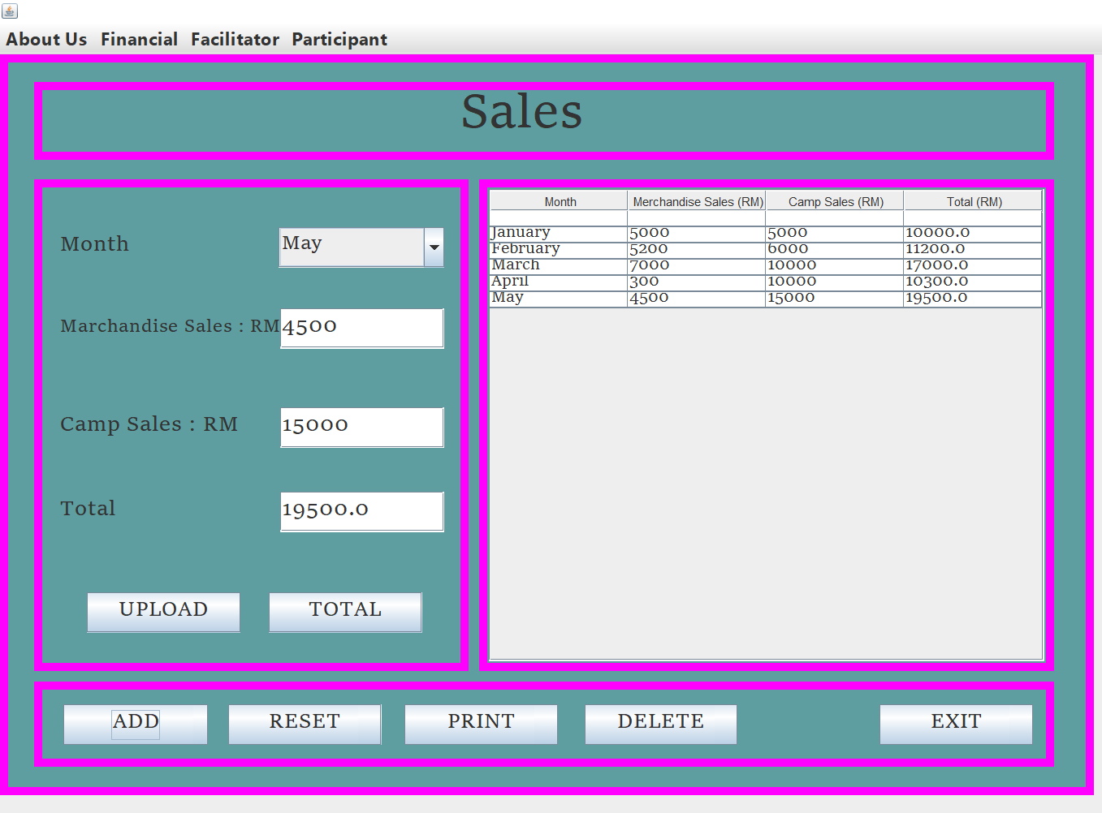

* **UPLOAD**

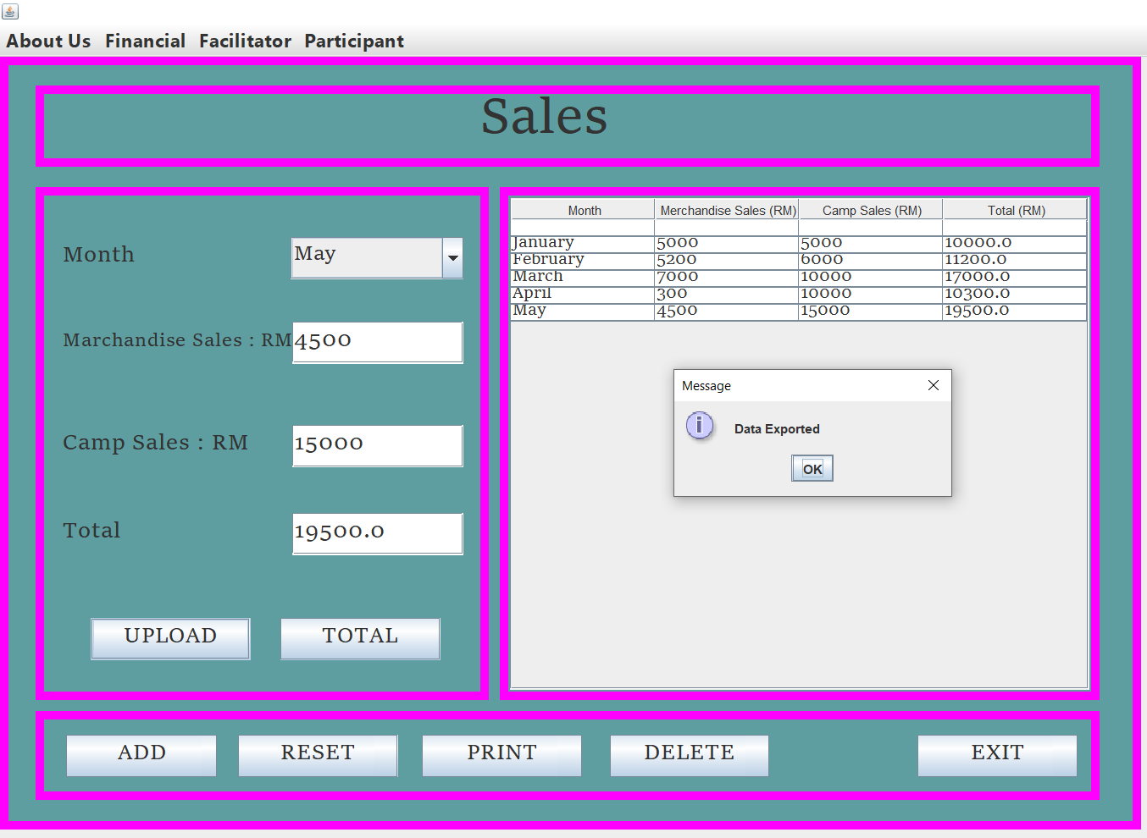

* **RESET**

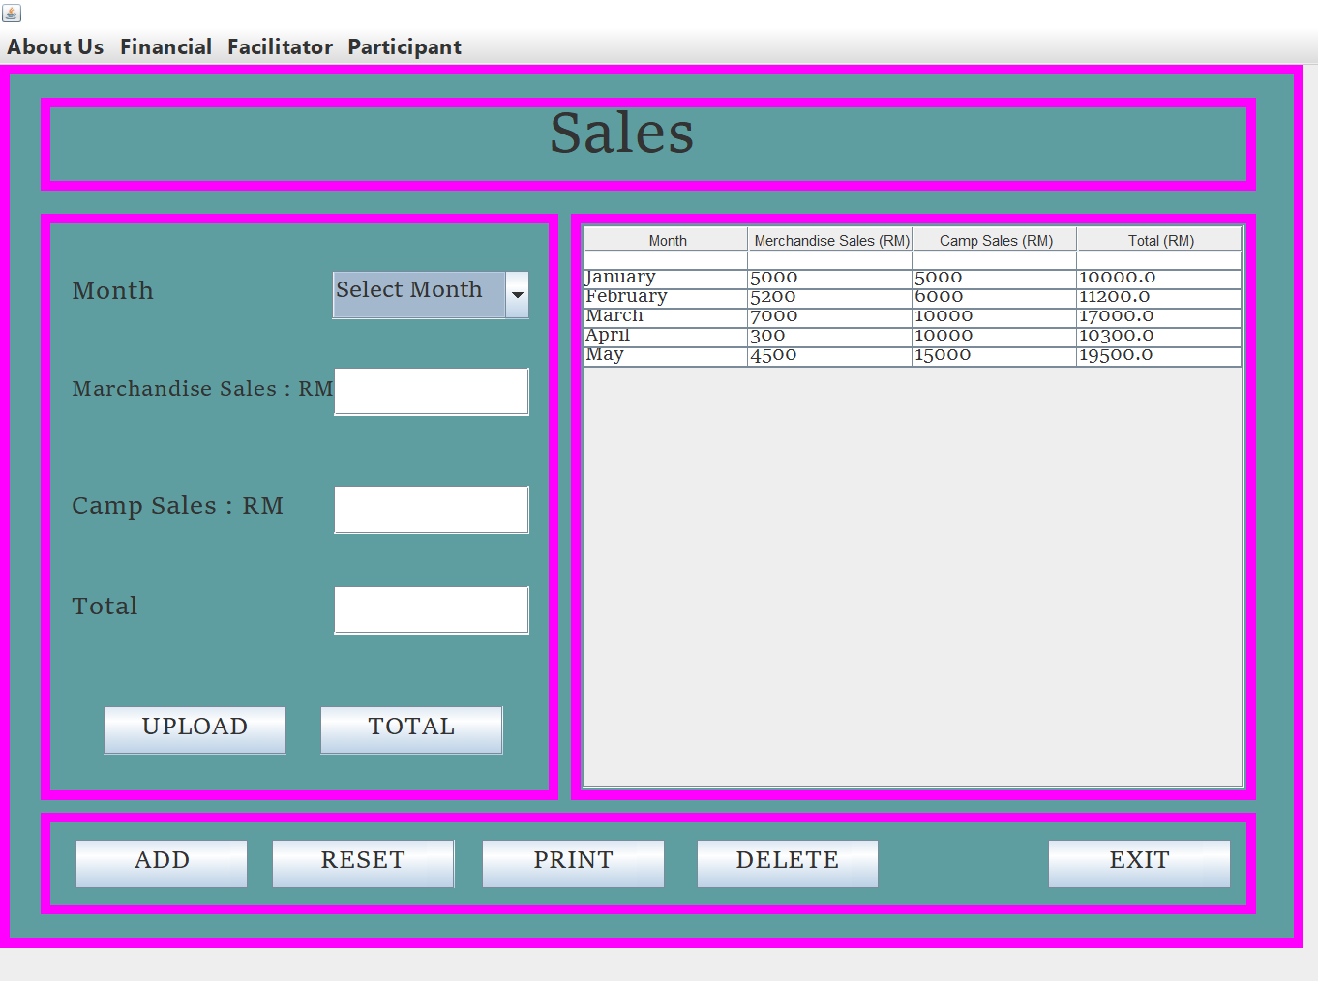

* **PRINT**

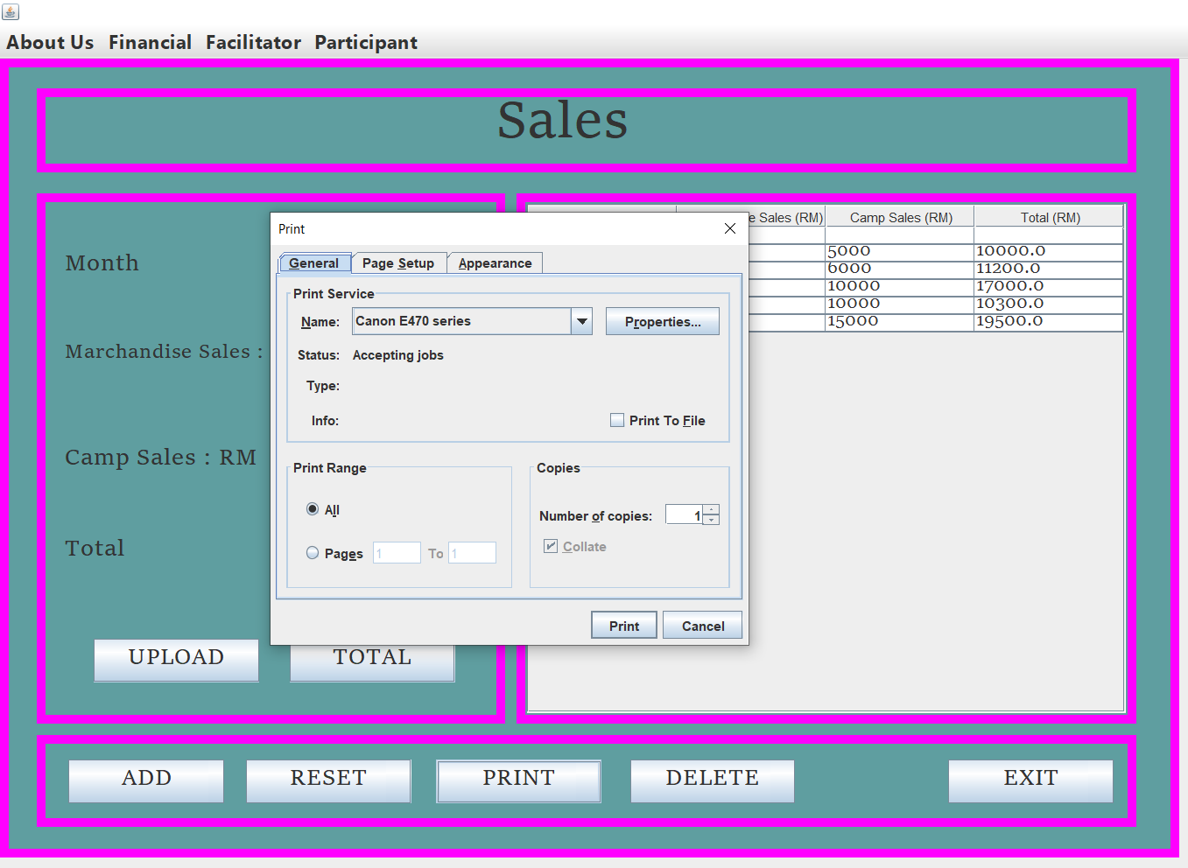

**DELETE**

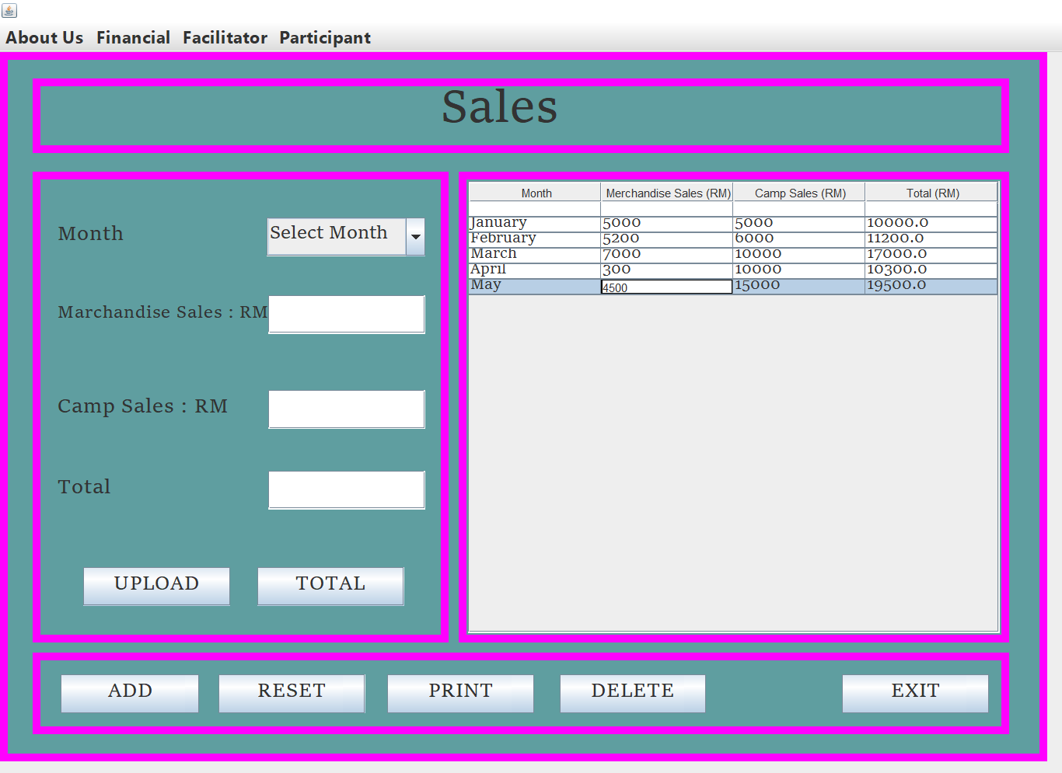

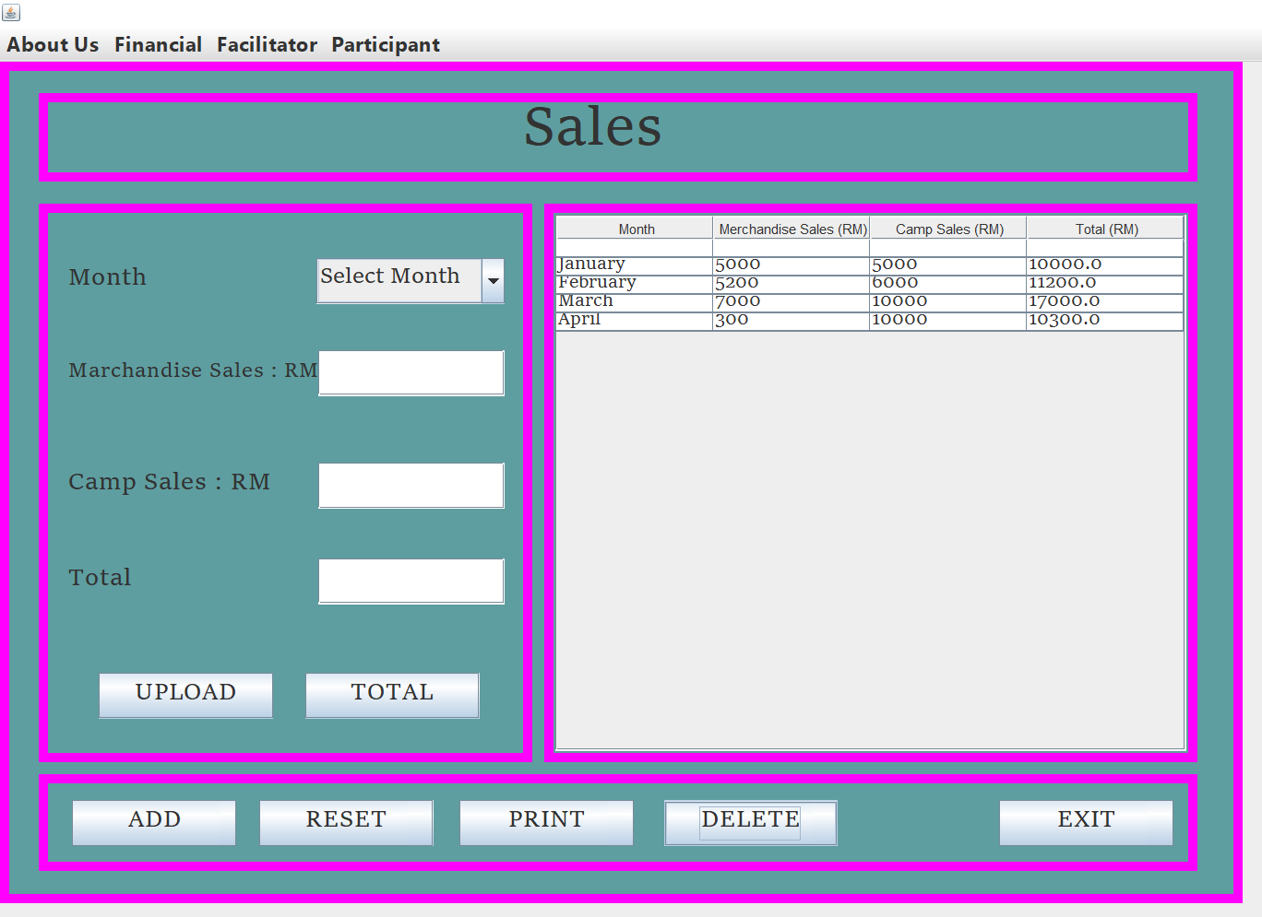

* **EXIT**

**PARTICIPANT REGISTRATION**

* **REGISTERS**

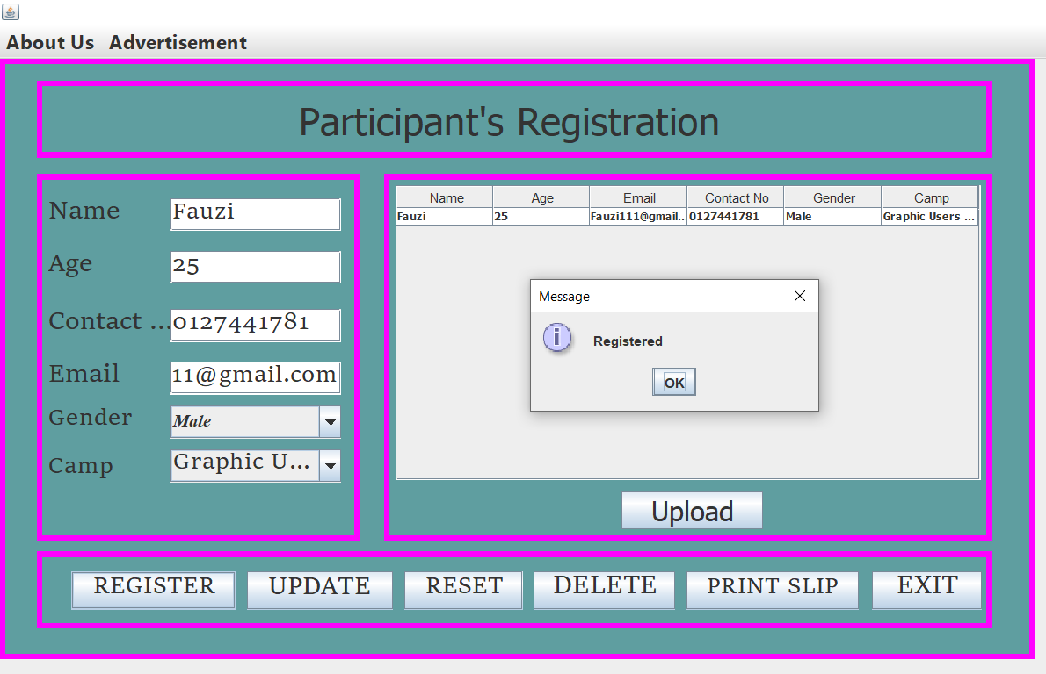

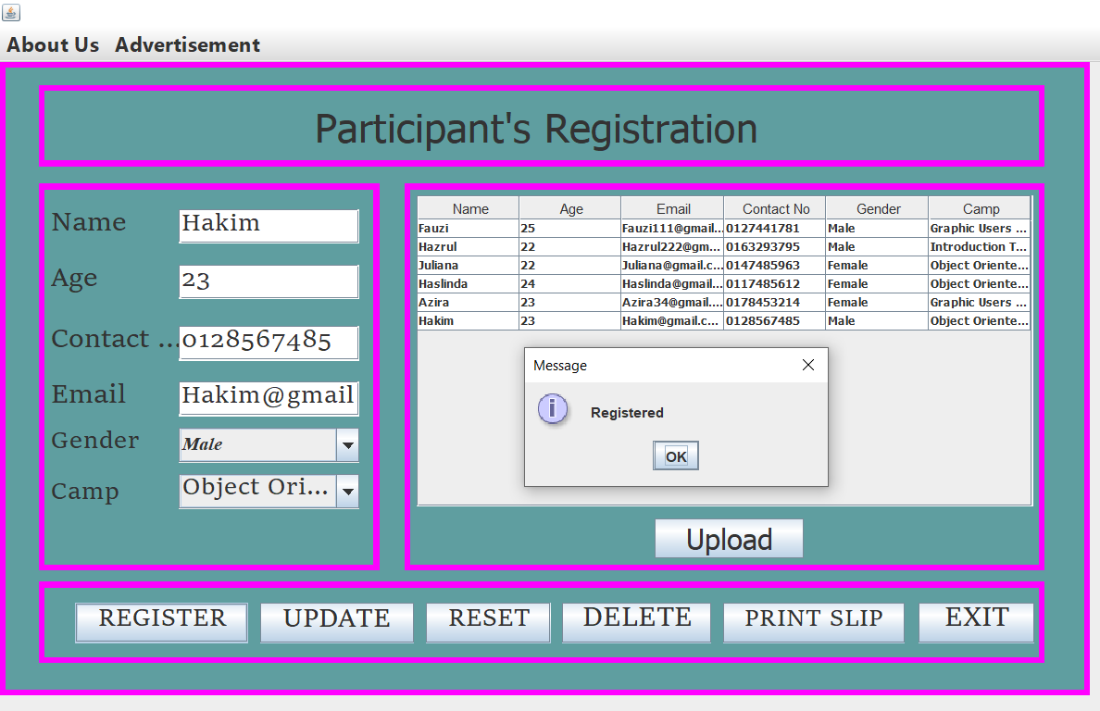

* **UPLOAD**

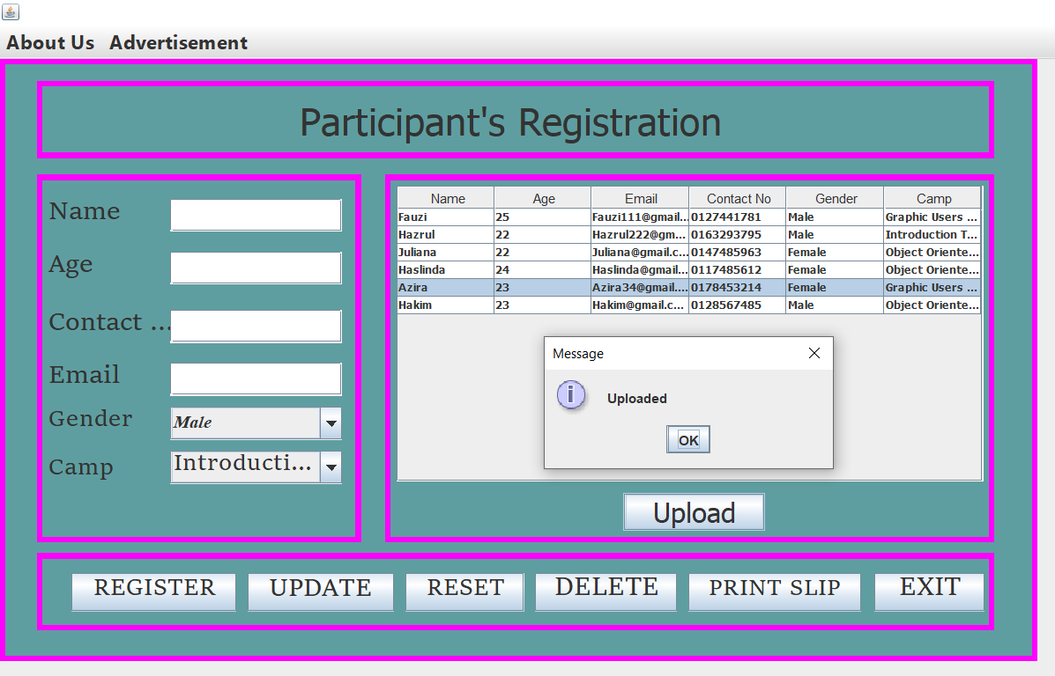

* **UPDATE**

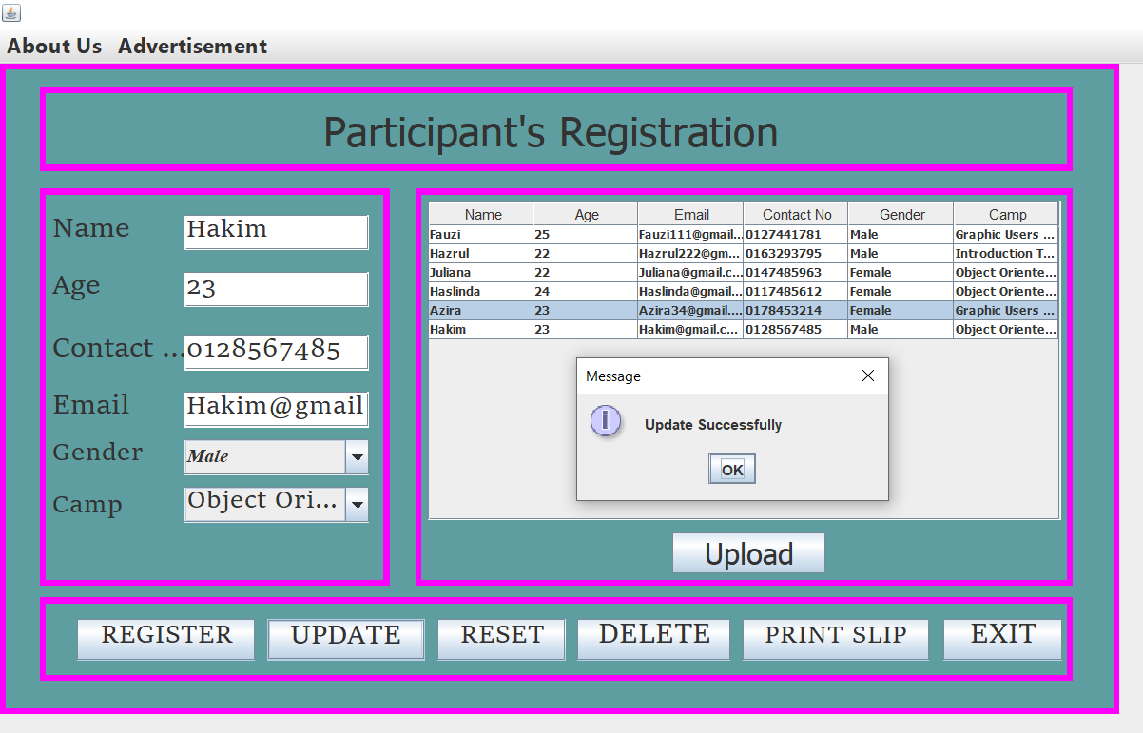

* **RESET**

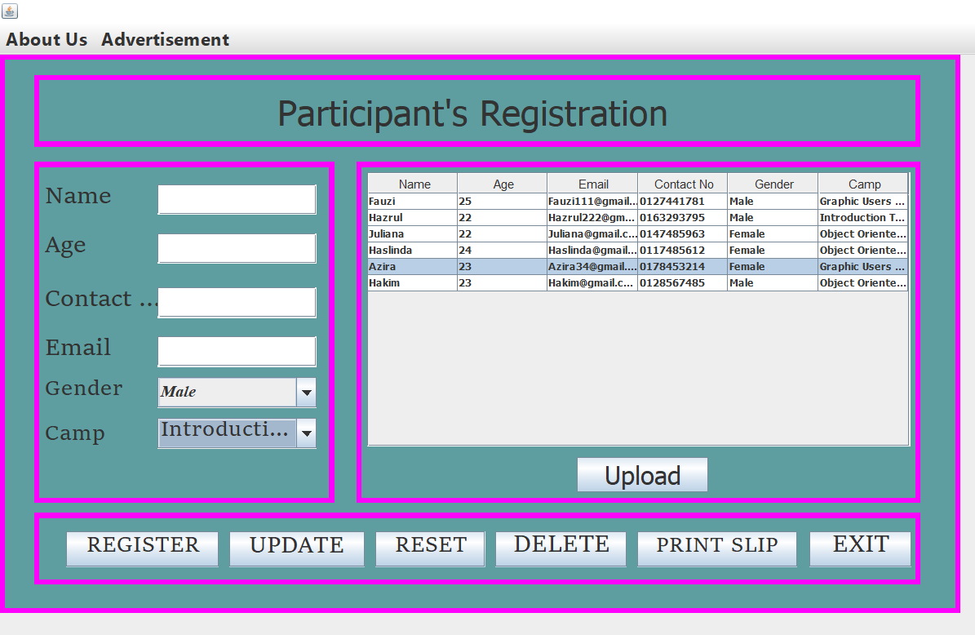

* **DELETE**

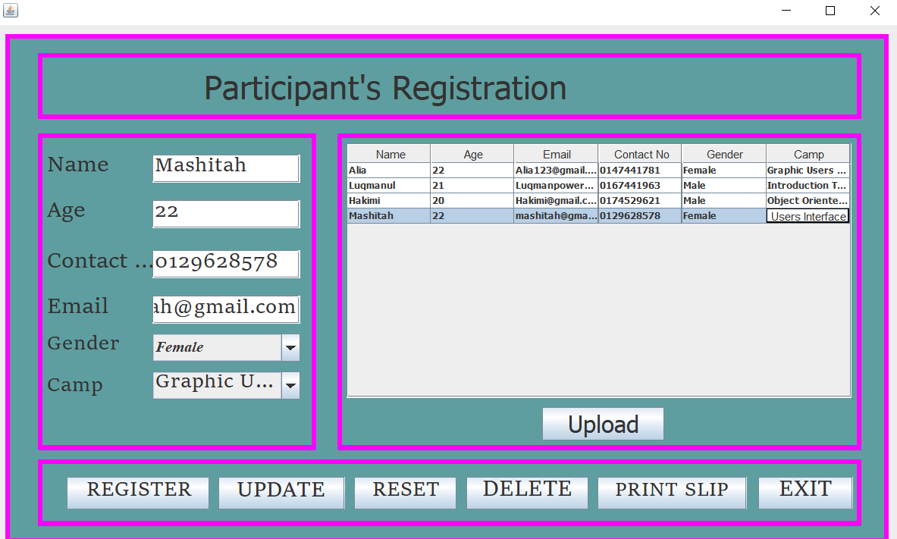

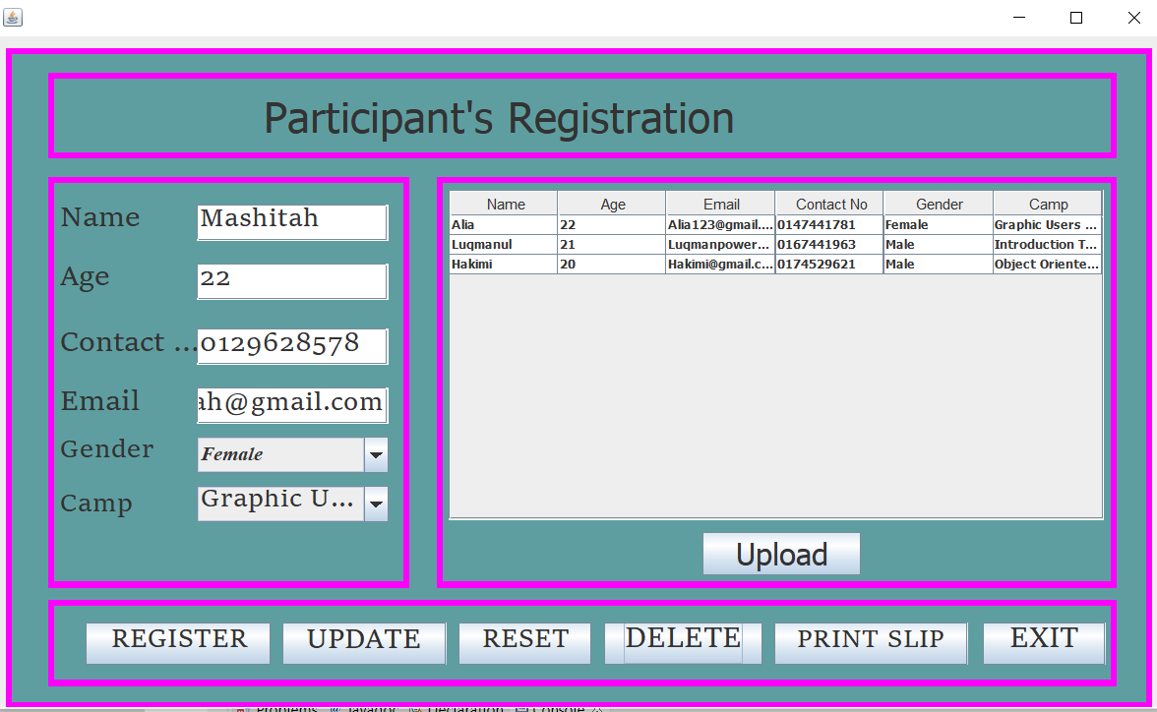

* **PRINT SLIP**

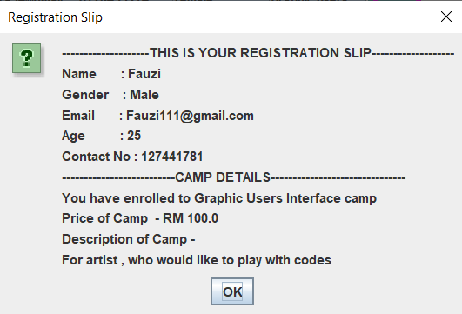

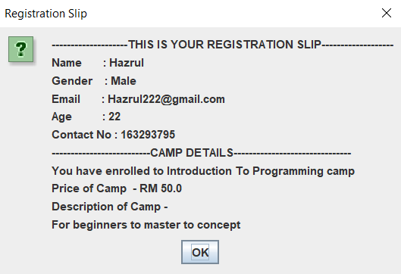

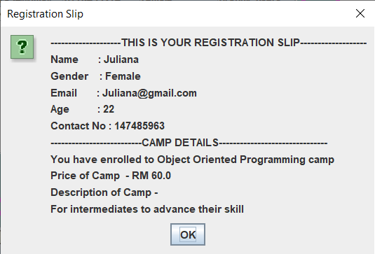

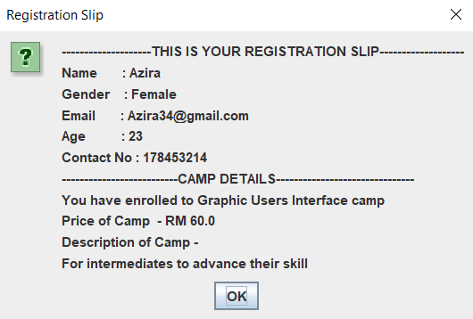

* **EXIT**



